**Version 1.0  
26 June 2013**

**Secure Web Integration Framework   
System/Subsystem Specification  
(SWIF SSS)**

***Code 53223***

*Further dissemination only as directed by Commanding Officer, Space and Naval Warfare Systems Center Pacific,   
San Diego, California 92152-5000, 26 June 2013, or higher authority.*

|  |
| --- |
|  |

**SSC Pacific  
San Diego, CA 92152-5001**

***This Page Intentionally Left Blank.***

(U) Record of Changes

*\*A - ADDED M - MODIFIED D – DELETED*

|  |  |  |  |  |  |
| --- | --- | --- | --- | --- | --- |
| VERSION NUMBER | DATE | NUMBER OF FIGURE, TABLE OR PARAGRAPH | * A M D | TITLE OR BRIEF DESCRIPTION | CHANGE REQUEST NUMBER |
| Original | 26Jun2013 | All | A | This is the initial version of this specification, developed using the SSC Pacific 5.0 Competency SSDD Template dated 04 December 2011, tailored where necessary. Content for several areas is still under development and needs additional coordination with stakeholders to finalize the SWIF System Design Description. | N/A |
|  |  |  |  |  |  |
|  |  |  |  |  |  |
|  |  |  |  |  |  |
|  |  |  |  |  |  |
|  |  |  |  |  |  |
|  |  |  |  |  |  |
|  |  |  |  |  |  |
|  |  |  |  |  |  |
|  |  |  |  |  |  |
|  |  |  |  |  |  |
|  |  |  |  |  |  |
|  |  |  |  |  |  |
|  |  |  |  |  |  |
|  |  |  |  |  |  |
|  |  |  |  |  |  |
|  |  |  |  |  |  |
|  |  |  |  |  |  |
|  |  |  |  |  |  |
|  |  |  |  |  |  |

(U) Table of Contents

Section Page

(U) Record of Changes iii

(U) Table of Contents iv

(U//FOUO) List of Figures vi

(U//FOUO) List of Tables viii

1. (U) SCOPE 1

1.1 (U) Identification 1

1.2 (U) Assumptions and Limitations 1

1.3 (U) System Overview 2

1.4 (U) Document Overview 8

2. (U) REFERENCED DOCUMENTS (StdV-1) 9

2.1 (U) Government References 9

2.1.1 (U) Specifications, Standards, and Handbooks 9

2.1.2 (U) Information Assurance Documents 9

2.1.3 (U) Government Open Source Software (GOSS) Documents 10

2.2 (U) Industry References 11

2.3 (U) Other Sources 11

3. (U) System-Wide Design Decisions 12

3.1 (U) Security and Privacy Design decisions 12

3.2 (U) Archtectural Design Decisions 12

3.3 (U) Web Client Design Decisions 12

4. (U) System Architectural Design 14

4.1 (U) Architectural Overview 14

4.2 (U) Key Challenges, Risks and Mitigation 16

4.3 (U) Design Methodology 16

4.4 (U) Capability Viewpoint 17

4.4.1 (U) SWIF Common Capabilities 18

4.4.2 (U) SWIF Mission Planning Domain Capabilities 29

4.4.3 (U) SWIF Target Domain Capabilities 32

4.4.4 (U) SWIF Capability Domain Capabilities 35

4.5 (U) Operational Viewpoint 38

4.5.1 (U) SWIF Roles 38

4.5.2 (U) SWIF Common Operations 40

4.5.3 (U) SWIF Mission Planning Operations 41

4.6 (U) Services Viewpoint 67

4.6.1 (U) SWIF Common Services 67

4.6.2 (U//FOUO) SWIF Planning Services 67

4.6.3 (U) SWIF Target Services 68

4.6.4 (U) SWIF Capability Services 68

4.7 (U) Systems Viewpoint 68

4.7.1 (U) SWIF Systems Interface Description (SV-1) 68

4.7.2 (U) SWIF Systems Resource Description (SV-2) 69

4.7.3 (U) SWIF System to System Matrix (SV-3) 69

5. (U) REQUIREMENTS TRACEABILITY 70

6. (U) NOTES 71

6.1 (U) Abbreviations (AV-2) 71

6.2 (U) Definitions (AV-2) 74

(U) APPENDIX A – Mission Planning Widget Mockups 75

(U) APPENDIX B – General Planning Workflow and Widget Mockups 81

(U//FOUO) List of Figures

Figure Page

Figure 1: (U) SWIF Vision (CV-1) 3

Figure 2: (U) SWIF Operational View OV-1 4

Figure 3: (U) SWIF UI Operational View OV-1 5

Figure 4: (U) SWIF Objective Architecture (OV-1) 6

Figure 5: (U) SWIF Objective Architecture (SvcV-1) 8

Figure 6: (U) DoDAF Architecture Overview 14

Figure 7: (U) SWIF Capability Vision (CV-1) 17

Figure 8 (U) SWIF Common Capability Taxonomy (CV-2) 18

Figure 9: (U) Data Security Activity Mapping (CV-6) 19

Figure 10: (U) Audit Activity Mapping (CV-6) 19

Figure 11: (U) Authentication and Authorization Activity Mapping (CV-6) 20

Figure 12: (U) Analytic Tools Activity Mapping (CV-6) 21

Figure 13: (U) Configuration Activity Mapping (CV-6) 22

Figure 14: (U) Export/Import Activity Mapping (CV-6) 22

Figure 15: (U) Group Management Activity Mapping (CV-6) 23

Figure 16: (U) Help Activity Mapping (CV-6) 23

Figure 17: (U) Notification Activity Mapping (CV-6) 24

Figure 18: (U) Preferences Activity Mapping (CV-6) 24

Figure 19: (U) Production Activity Mapping (CV-6) 25

Figure 20: (U) Search Activity Mapping (CV-6) 25

Figure 21: (U) Subscriptions Activity Mapping (CV-6) 26

Figure 22: (U) User Account Management Activity Mapping (CV-6) 26

Figure 23: (U) Usage and Performance Activity Mapping (CV-6) 27

Figure 24: (U) Visualization Activity Mapping (CV-6) 27

Figure 25: (U) Workflow Management Activity Mapping (CV-6) 28

Figure 26: (U) SWIF Common Capability to Services Mapping (CV-7) 29

Figure 27: (U) SWIF Planning Capability Taxonomy (CV-2) 30

Figure 28: (U) Planning Activity Mapping (CV-6) 31

Figure 29: (U) SWIF Planning Capability to Services Mapping (CV-7) 32

Figure 30: (U)SWIF Target Domain Capability Taxonomy (CV-2) 33

Figure 31: (U) SWIF Target Domain Activity Mapping (CV-6) 34

Figure 32: (U) SWIF Target Domain Capability to Service Mapping (CV-7) 35

Figure 33: (U)SWIF Target Domain Capability Taxonomy (CV-2) 36

Figure 34: (U) SWIF Target Domain Activity Mapping (CV-6) 37

Figure 35: (U) SWIF Capability Domain to Service Mapping (CV-7) 38

Figure 36: (U) External Organizations Relation (OV-4) 42

Figure 37: (U) Generic Mission Planning Operational Scenario 44

Figure 38: (U) SWIF Mission Planning Development Scenario II 45

Figure 39 (U) SWIF Plan Development Scenario (OV-5B) 52

Figure 40. (U) Create CONOP (OV-5B) 62

Figure 41: (U) Receive Tasking Request Activity (OV-5b) 62

Figure 42: (U) Plan Editor: Summary (OV-5B) 63

Figure 43: (U) Plan Editor: Targeting (OV -5b) 64

Figure 44: (U) Create Report Activity (OV-5B) 64

Figure 45: (U) Associate Targets Activity (OV-5B) 65

Figure 46: (U) Associate Targets Activity (OV-5B) 66

Figure 47: (U) Associate Capabilities Activity (OV-5B) 66

Figure 48: (U) Analyze Targets and Capabilities Activity (OV-5B) 67

Figure 49: (U) Analyze Targets and Capabilities Activity (OV-5B) 67

Figure 50: (U) SWIF Systems Interface Description 69

Figure 51: (U) Widget Mockup: Plan Editor: Summary Tab 75

Figure 52: (U) Widget Mockup: Plan Editor: Scheduling Tab 76

Figure 53: (U) Widget Mockup: Target Search 77

Figure 54: (U) Widget Mockup: Target Details Read Mode 78

Figure 55: (U) Widget Mockup: Target Details Edit Mode 79

Figure 56: (U) Widget Mockup: Capability Search 80

Figure 57: (U) Widget Mockup: Capability Details 80

Figure 58: (U) Widget Mockup: CONOP Editor 80

Figure 59: (U//FOUO) General Planning Workflow 82

Figure 60: (U//FOUO) Plan Editor Widget 83

Figure 61: (U//FOUO) Plan Editor Widget 83

Figure 62: (U//FOUO) Plan Setup 84

Figure 63: (U) Capability Research 85

Figure 64: (U) Target System Analysis 86

Figure 65: (U) Target System Analysis 87

Figure 66: 7 (U) Option Development 88

Figure 67: (U) Capability Assignment 89

Figure 68: (U) Capability Assignment 90

Figure 69: (U) Final Option Selection 91

Figure 70: (U) Target CONOPS Development 92

Figure 71: (U) SWIF Widget Set 93

Figure 72: (U//FOUO) Plan Edit Widget Summary 94

Figure 73: (U//FOUO) Plan Editor Widget, Targeting Tab 95

Figure 74: (U) L1 Targeting Properties 96

Figure 75: (U) L2 Targeting Properties 96

Figure 76: (U) L3 Targeting Properties 97

Figure 77: (U) Analyst Workflow 97

(U//FOUO) List of Tables

Table 1(U) SSDD DID to DoDAF View Mapping 15

Table 2: (U) Key Challenges, Risks and Mitigation 16

Table 3: (U) SWIF User Roles 39

Table 4: (U//FOUO) SWIF Planning Roles 40

Table 5: (U//FOUO) SWIF Plan Development Scenario Legend 53

Table 6: (U) Analyst Workflow Scenario (OV-5B) 53

Table 7: (U) Planner Workflow Scenario (OV-5B) 56

Table 8: (U) Provider Workflow Scenario (OV-5B) 58

Table 9: (U) Provider Workflow Scenario (OV-5B) 60

Table 10: (U) Visualization Scenario (OV-5B) 60

# (U) SCOPE

(U) This System/Subsystem Design Description (SSDD) identifies the system-wide architectural design for the Secure Web Integrated Framework (SWIF).

(U) This SSDD, with associated [*not yet completed*] Interface Control Documents (ICDs) and Database Design Description (DBDD), will serve as the basis for further system development. The SWIF Project Manager (PM) assumes responsibility for this document and will update it as required to meet the needs of the targeted deployment network.

(U) Updates to this document will be in accordance with the SWIF Configuration Management Process [*to be defined*]. All requirement changes that affect this document will be reviewed with the sponsor and the PM for concurrence so that the impacts of the changed requirements with respect to cost, schedule, and performance are understood. Please refer to the SWIF Requirements Management Process for additional information.

Note: Confirm if the SWIF Requirements Management Process will be developed for SWIF

Note: Confirm if the SWIF Requirements Management Process will be developed for SWIF

(U) This document describes the main aspects and features of SWIF. The architecture described in this document reflects the functional goals of the objective system. The *objective system* is a term to represent the final end state of the system. It is recognized, however, that objectives and requirements change over time and that the actual end SWIF system may deviate from that proposed in this document. It is important to define and document the objective system as it is envisioned at any phase of development.

(U) The architecture presented here will be implemented in a phased approach, and will be designed and developed over a number of spirals. The requirements identified in this document are focused on the objective system, as are the requirements identified in the SWIF *System /Subsystem Specification (SSS)*. Both this document and the SSS are living documents that will be modified as detailed design reveals additional considerations that must be addressed. Detailed design will be documented in Software Design Descriptions (SDDs), which are expected to further capture derived requirements . This document provides the high level conceptual architecture for the SWIF system. In the event of conflict between this document and the contents of the SDD documents relative to segment design and development, the SSS shall be considered the governing document. The degree of implementation within each planned spiral is driven by the program’s budget and schedule.

(U) The format for this specification is based on the SSC Pacific Engineering (5.0) Competency *System/Subsystem Design Description (SSDD) Template* (TM-TS-04 v1.1) and the SSS Data Item Description (DID; DI-IPSC-81432A; see section 2).

## (U) Identification

(U) This document applies to the objective SWIF system baseline. Requirements pertaining to the SWIF external interfaces are covered in separate ICDs.

## (U) Assumptions and Limitations

(U) The purpose of this document is to describe the objective architecture of SWIF. The SWIF architecture is documented at a high level only for two reasons:

* Technology will change by the time some SWIF components are to be developed; we want SWIF to be able to take advantage of new technologies when implementing the objective architecture.
* Not all SWIF requirements are currently known and will likely change over time. We want the SWIF architecture document to be a guide and to be technology and implementation agnostic to allow for maximum flexibility.

(U) This document assumes the reader is familiar with current Web, enterprise and database Technologies. Section 2 provides references to these technologies only and does not discuss how these third-party technologies and architectures function.

## (U) System Overview

(U) The Secure Web Integrated Framework (SWIF) is a Web application with the following objective goals as depicted in Figure 1 [*under development*]:

* Provide a security component for the use by any widget framework
* Allow third parties to use SWIF as a framework for developing secure Protection Level 3 (PL-3) enterprise web applications based on the users authenticated access (clearance level).
* Provide a core set of services/components that are required by PL-3 systems, common to an enterprise solution.
* Provide a core set of services and widgets that can be used to support enterprise services mission planning and target analysis domains.
* Provide a capability to allow SWIF data to be shared between multiple, separate and physically disconnected SWIF deployment installations.

Note: Confirm if Figure 1 (Simplified vision) is desired or SWIF Team to provide update.

Note: Confirm if Figure 1 (Simplified vision) is desired or SWIF Team to provide update.



[Figure is Unclassified]

1. Figure : (U) SWIF Vision (CV-1)

(U) SWIF provides an additional security infrastructure that allows widgets to meet a target systems security requirements related to Mandatory Access Control (MAC), Discretionary Access Control (DAC) and Attribute Based Access Control (ABAC).

(U) The following figure displays the objective state of the SWIF capability. Widgets are accessed by users to perform their duties and functions. Information entered by the user or displayed within a SWIF widget will have the ability to have classification setting applied to the data. This will ensure users perform activities based on their role and accesses. When required, the user can generate a report and post it to an external source that can be imported to a SWIF system in support of planning activities for another customer.

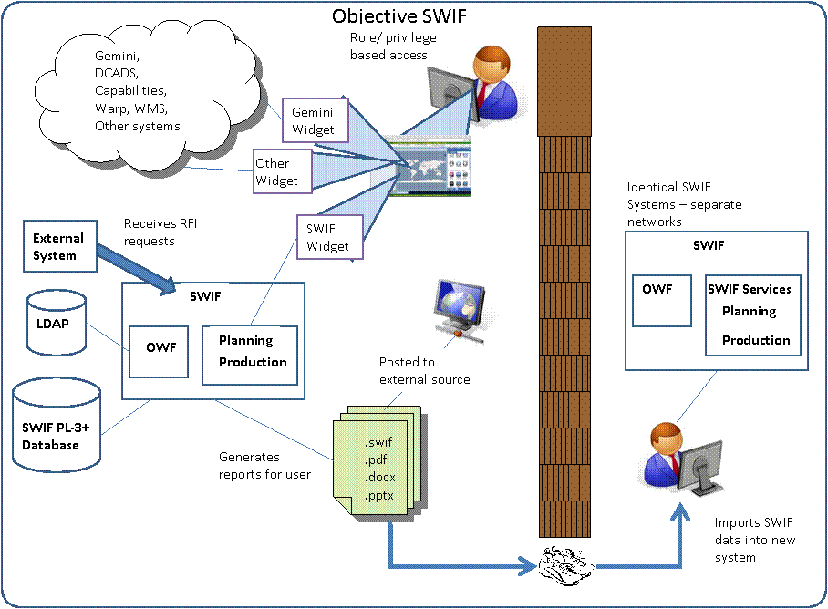

[Figure is **U//FOUO**]

1. Figure : (U) SWIF Operational View OV-1

(U) The following figure is a view of the Objective SWIF User Interface (UI):

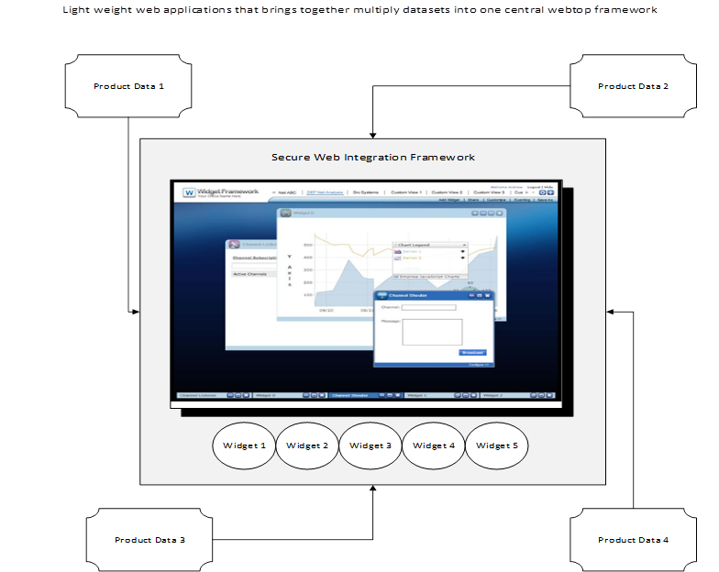

[Figure is Unclassified]

Figure : (U) SWIF UI Operational View OV-1

(U) SWIF will be designed and developed over a number of spirals. The requirements identified in the SSS focus on the objective system, as is the initial design described in this document. Both this document and the SSS are living documents that will be modified as detailed design reveals additional considerations that must be addressed. The SDDs are expected further to capture derived requirements.

(U) The following two figures represent the objective architecture of SWIF depicted as a pluggable architecture (OV-1) and the representative service stack (Svc-1). The SWIF OV-1 diagram shows how SWIF will allow third party developers to use the SWIF framework to create and deploy additional W applications to support additional domains. Each domain will have the flexibility to use information created by another domain.



[Figure is Unclassified]

Figure : (U) SWIF Objective Architecture (OV-1)

(U) The following diagram represents the layers of the objective SWIF system depicted as a *wedding cake* diagram. A typical wedding cake diagram shows a system as a series of *layers* where each layer is typically dependent on the layers below it. In the following diagram for example, the Domain Layer uses services defined by the Common Services Layer, which uses services defined in the Persistence Layer, Authentication Layer, and the layers below that, etc.



[Figure is Unclassified]

1. Figure : (U) SWIF Objective Architecture (SvcV-1)

(U) Where applicable and/or required, SWIF design will comply with open source and the other standards; custom standards will be implemented only if no other standard exists.

(U) SWIF currently consists of a Web application with REST services exposed for external users. SWIF also provides a JavaScript component that can be used by third party developers for authentication into the SWIF server, and for setting classification of the data displayed on a Web page.

## (U) Document Overview

(U) This SSDD is organized into the following sections:

* **Section 1: Scope** — Provides the scope, the identification, and a summary of the contents of the SSDD.
* **Section 2: Referenced Documents** — Lists the number, title, revision, and date of all referenced documents.
* **Section 3: System-Wide Design Decisions** — Defines decisions about the design of the system's behavior and other decisions affecting the selection and design of system components.
* **Section 4: System Architectural Design** — Describes the system architectural design.
* **Section 5: Requirements Traceability** — Provides traceability from each requirement imposed on the entity in this specification to the system (or subsystem, if applicable) requirements it addresses.
* **Section 6: Notes** — Contains information of a general or explanatory nature.
* **Appendix A** — Acronyms and Abbreviations

# (U) REFERENCED DOCUMENTS (StdV-1)

(U) This section lists the specifications, standards, manuals, and other documents, including policy directives, referenced or used as source material for this document.

## (U) Government References

### (U) Specifications, Standards, and Handbooks

(U) The following specifications, standards, and handbooks form a part of this document to the extent specified herein.

* Data Item Description, System/Subsystem Design Description (SSDD), DI-IPSC-81431A, 08/10/1999
* Department of Defense Architecture Framework (DoDAF) Version 2.0.2. <http://dodcio.defense.gov/Portals/0/Documents/DODAF/DoDAF_v2-02_web.pdf>
* Joint Operation Planning , Joint Publication 5-0, 11 August 2011 <http://www.dtic.mil/doctrine/new_pubs/jp5_0.pdf>
* MIL-STD-1472G Department of Defense Design Criteria Standard Human Engineering, 11 January 2012, <http://quicksearch.dla.mil/basic_profile.cfm?ident_number=36903&method=basic>
* Section 508 of the Rehabilitation Act of 1973 Technical Guide, Version 3.30, <http://www.uspto.gov/about/offices/cio/section508/guide_index.jsp>

### (U) Information Assurance Documents

#### (U) Federal

* Public Law (P.L.) 107-347, The E-Government Act of 2002, Title III, Information Security, Commonly known as the Federal Information Security Management Act of 2002 (FISMA).
* Public Law 100-235, “Computer Security Act of 1987,” January 8, 1988.
* OMB Circular A-123, "Management Accountability and Control," June 21, 1995.
* OMB Circular A-130 (Revised), Transmittal Memorandum No. 4 “Management of Federal Information Resources,” Appendix III, “Security of Federal Automated Information Resources,” November 30, 2000.
* Americans with Disabilities Act Accessibility Guidelines for Buildings and Facilities (ADAAG), 2004, <http://www.access-board.gov/adaag/about/index.htm>.
* National Technology Transfer and Advancement Act of 1995, (Public Law 104-113), 7 March 1996, <http://frwebgate.access.gpo.gov/cgi-bin/getdoc.publ113.104.pdf>.
* Uniform Federal Accessibility Standards (UFAS), 1984. <http://www.access-board.gov/ufas/ufas-html/ufas.htm>.

#### (U) DEPARTMENT OF DEFENSE

* Chairman of the Joint Chiefs of Staff Instruction CJCSI 6212.01D, Interoperability and Supportability of Information Technology and National Security Systems, March 8, 2006.
* Department of Defense Directive (DoDD) 5200.l R, Information Security Program, January 1997.
* Department of Defense Acting CIO Memorandum, Clarifying Guidance on Open Source Software, 16 October 2009.
* DoDD 8500.1, Information Assurance (IA), October 24, 2002.
* DoDI 8500.2, Information Assurance (IA) Implementation, February 6, 2003.
* <http://www.dtic.mil/whs/directives/corres/pdf/850002p.pdf>
* DoDI 4630.8, Procedures for Interoperability and Supportability of Information Technology (IT) and National Security Systems (NSS), June 30, 2004
* DoDI 8510.01, DoD Information Assurance Certification and Accreditation Process (DIACAP), November 28, 2008.
* Intelligence Community Directive 503 (ICD 503) Information Technology Systems Security Risk Management, Certification and Accreditation, Effective 15 September 2008
* DCID 6/3, Director of Central Intelligence Directive (DCID) 6/3, Protecting Sensitive Compartmented Information within Information Systems, 9 June 1999, Administratively updated 1 May 2003
* DCID 6/6, Director of Central Intelligence Directive (DCID) 6/6, Security Controls on the Dissemination of Intelligence Information, 11 July 2001, Administratively updated 20 January 2004
* NIST 800-53 Recommended Security Controls for Federal Information Systems and Organizations, <http://csrc.nist.gov/publications/nistpubs/800-53A-rev1/sp800-53A-rev1-final.pdf> , August 2009, <http://csrc.nist.gov/publications/nistpubs/800-53-Rev3/sp800-53-rev3-final_updated-errata_05-01-2010.pdf>
* XML Data Encoding Specification for Information Security Marking Metadata V9 (ISM.XML.V9) 17 July 12 <http://www.dni.gov/files/documents/CIO/ICEA/ISMPublic.zip>

#### (U) DEFENSE INFORMATION SYSTEMS AGENCY (DISA)

(U) Find the following at <http://iase.disa.mil/> (note: these change frequently so specific versions are not included here):

* Security Technical Implementation Guides (STIGs)
* Security Readiness Review Scripts (SRRs)
* Gold Disks
* Security

### (U) Government Open Source Software (GOSS) Documents

* OZONE Widget Framework Developers Guide 21 December, 2012 <https://s3.amazonaws.com/org.ozoneplatform/OWF/7-GA/OWF-help-7-GA.zip>
* OZONE Widget Framework Users Guide 21 December, 2012 <https://s3.amazonaws.com/org.ozoneplatform/OWF/7-GA/OWF-help-7-GA.zip>
* OZONE Widget Framework Configuration Guide 21 December, 2012 <https://s3.amazonaws.com/org.ozoneplatform/OWF/7-GA/OWF-help-7-GA.zip>

#### (U) Project Documents

* SWIF System/Subsystem Design Description (SSDD), Version 1.0, 26 June 2013

## (U) Industry References

(U) The following documents form a part of this plan to the extent specified. In the event of conflict between the documents referenced and the contents of this plan, the contents of this plan shall be considered a superseding requirement.

* The Java Virtual Machine Specification, Second Edition Lindholm, Yellin ISBN 0-201-43294-3, copyright 1999.
* The Java Language Specification, Third Edition Gosling, Joy, Steele, Bracha ISBN 0-321-24678-01, copyright 2005.
* [Extensible Markup Language (XML) 1.0 (Fourth Edition)](http://www.w3.org/TR/2006/REC-xml-20060816/) W3C Recommendation 16 August 2006, Tim Bray, Jean Paoli, C. M. Sperberg-McQueen, Eve Maler, François Yergeau eds.
* ISO/IEC 9075: 1992 Information Technology – Database Language – SQL with amendment 1, 1996, as modified by FIPS Publication 127-2:1993, Database Language for Relational DBSMSs (Entry level SQL)
* ISO/IEC 9075-3: 1995 Information Technology – Database Languages – SQL – Part 3: Call-Level Interface (SQL/Call Level Interface (CLI))
* JavaScript Objective Notation (JSON) RFC 4627 July 2006, <http://www.ietf.org/rfc/rfc4627.txt>
* Ozone Widget Framework (OWF) <https://www.owfgoss.org/>
* Ozone Synapse SDK v3.0 <http://widget.potomacfusion.com/pageDisplay/index?menuid=6&pageid=4>
* Java Coding Style Guide Sun Microsystems, 5/2000 <http://developers.sun.com/sunstudio/products/archive/whitepapers/java-style.pdf>
* RFC793 Transmission Control Protocol (TCP)
* RFC801 Internet Protocol (IP) Version 4

## (U) Other Sources

The following sources were used in addition to the prior sections in the creation of this document:

* The deployed Unclassified SWIF prototype, accessible from the SPAWAR RDT&E Network: <https://swif2.sd.spawar.navy.mil/owf>The unclassified SWIF Baseline Software accessible from the SPAWAR RDT&E located at: <https://cmsource.sd.spawar.navy.mil/svn/FAD/trunk>
* The unclassified SWIF developers notes located at https://cmsource.sd.spawar.navy.mil/confluence/display/ICER

# (U) System-Wide Design Decisions

## (U) Security and Privacy Design decisions

| Decision ID | Description |
| --- | --- |
| DD-001 | The system will meet PL-3+ requirements |
| DD-002 | Initially, data will be be protected using Mandatory Access, Discretionary Access Controls; Attribute Access Controls may be added in a future version |
| DD-003 | The data design will allow security labels to be defined in data and will not be hard coded. |

[Table is Unclassified]

## (U) Archtectural Design Decisions

| Decision ID | Description |
| --- | --- |
| DD-003 | SWIF will be designed such that it will be a framework providing PL-3 common services usable by others (e.g., similar to how OWF is a framework) to create additional domain functionality and application domains. SWIF will also include three application domains, Planning Targeting and Capabilities. |
| DD-004 | SWIF will be designed and deployed in such a way that core and application services will be separate; common services will be able to be reused by third party developers as part of the framework to provide PL-3 enterprise services to other domain applications. |
| DD-005 | SWIF will rely on a third party package “Central Authentication Service” (CAS) and Spring Security initially. |

[Table is Unclassified]

## (U) Web Client Design Decisions

| Decision ID | Description |
| --- | --- |
| DD-004 | The SWIF web client and service/presentation layers will be designed and deployed in such a way that other web frameworks can be added and/or replaced without impacting existing web clients. (e.g., plug and play) |
| DD-005 | Changes/updates to SWIF server logic will remain backwards compatible to third party SWIF Widgets |
| DD-006 | Server side REST services will remain backwards compatible to any prior REST service version. |

[Table is Unclassified]

# (U) System Architectural Design

## (U) Architectural Overview

(U) The Data Item Description (DID) specification for the sections of an SSDD dos not map clearly to either the DoDAF architecture or to a SOA for a Web application. DoDAF does a very good job at documenting a System of Systems; however, it can fall short in some cases when used to document a software application. To mitigate this issue we have provided a table mapping design artifacts between the SSDD DID sections, DoDAF viewpoints, and UML Viewpoints.

(U) The SWIF Architecture document focuses on a subset of the following viewpoints: Capability, Operational, Service, and Systems. The Standards Viewpoint (StdV-1) is documented in Section 2 of this document. DoDAF architecture overview is depicted in the following figure:

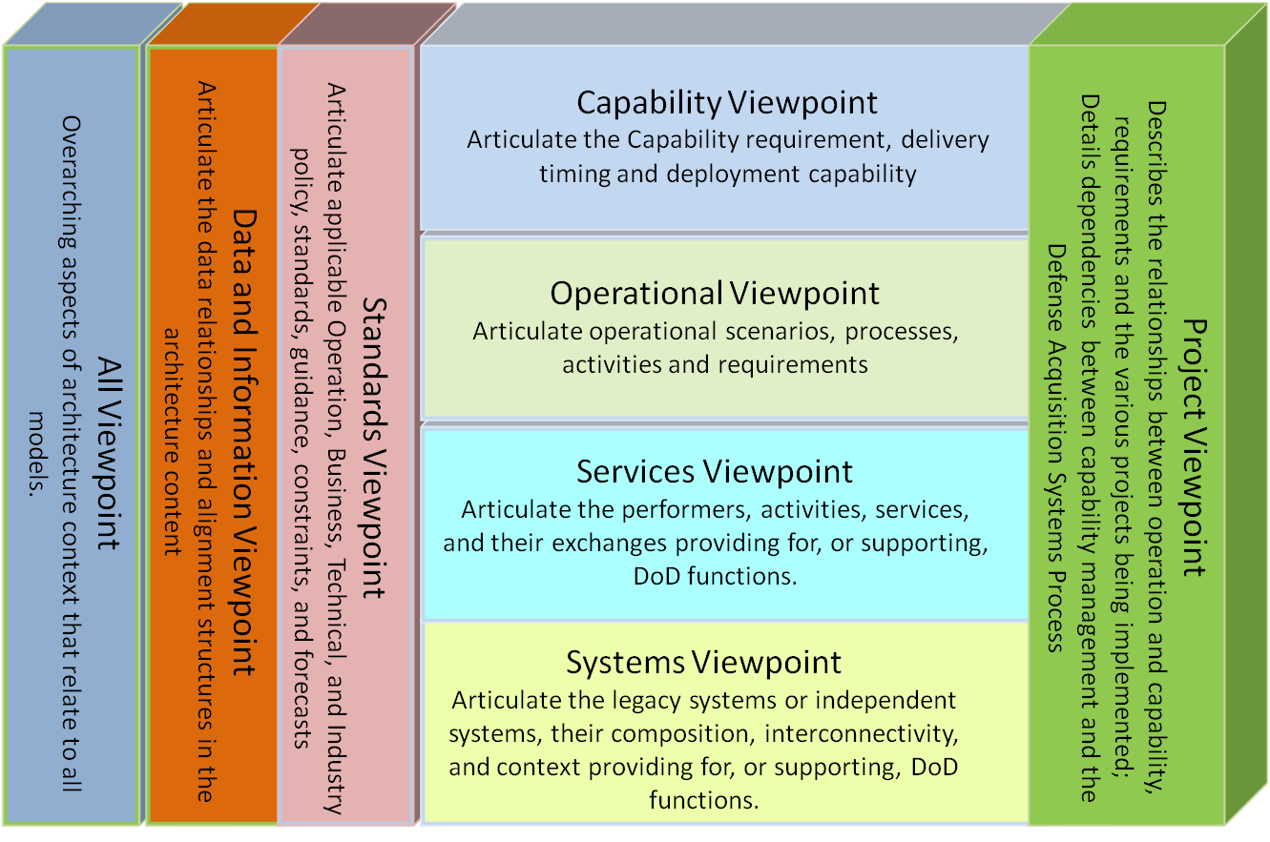

*[Figure is Unclassified]*

Figure : (U) DoDAF Architecture Overview

(U) The following table maps the SSDD DID Section 4 section requirements to those defined in the SWIF SDD section 4.

Table : (U) SSDD DID to DoDAF View Mapping

*[Table is Unclassified]*

| SSDD DID Section Number and Title | SWIF SSDD Section number and Title (DoDAF Views) | UML Viewpoints |
| --- | --- | --- |
| 4.0 System Architectural Design | 4.0 System Architectural Design  4.1 Architectural Overview  4.2 Key Challenges, Risks and Mitigation  4.3 Design Methodology |  |
| 4.1 System Components | 4.4 Capability Viewpoint | Use Cases |
| 4.6 Services Viewpoint | Component, Communication, Activity, Sequence |
| 4.7 Systems Viewpoint | Component, Communication, Activity, Sequence |
| 4.2 Concept of Execution | 4.5 Operational Viewpoint | Use Cases, Activity, Component, Deployment |
| 4.2 Interface Design | Not covered in this document.  Documented in the associated Component SDD and in the SWIF ICD. |  |

*[Table is Unclassified]*

## (U) Key Challenges, Risks and Mitigation

Table : (U) Key Challenges, Risks and Mitigation

*[Table is Unclassified]*

| ID | Challenge/Risk | Mitigation |
| --- | --- | --- |
| 001 | Relying on a third party package (OWF) for the SWIF deployment container. | Investigate and track alternative widget packages; migrate SWIF services and widgets to execute in a separate standalone container from OWF; migrate SWIF authentication to a non OWF solution. |
| 002 | Relying on a third party package (Synapse) for the inter-Widget communication. | Investigate and track alternative widget communication packages. |
| 003 | Ensuring that a given SWIF web application deployment can scale on demand to meet user needs | Investigate Elastic Load Balancing, and deploy SWIF in such a way that it can scale based on demand. |
| 004 | Row and attribute label access to data will cause the system to slow. | Investigate alternative database solutions; perform analysis of alternatives (trade) study that focuses on performance under load. |
| 005 | SWIF will not be able to update/incorporate emerging technologies in a timely manner (won’t be able to keep up w/ new trends fast enough) | Create a prototyping/proof of concept effort in parallel with developing the SWIF baseline; consider providing ‘beta’ capabilities w/ each SWIF release to get user and performance feedback |

*[Table is Unclassified]*

## (U) Design Methodology

(U) To optimize design and development time, a modified software engineering process will be used that combines features from both the agile and spiral development methodologies. This will allow the SWIF develop team to focus on a solution-derived design rather than a requirements-derived solution within short time frames.

(U) The SWIF process also uses a Scenario driven approach in which the main interaction of system users, both internal and external, is captured through use case and/or activity sequence diagrams. At this level of design, these diagrams allow the SWIF team to determine the main interactions that must be supported so that top-level requirements can be satisfied. The scenarios are defined in the Operation Viewpoint section of this document.

(U) A Concept of Operations (CONOP) for the design/implementation of widgets is documented in the SWIF Developers Guide. The SSDD will document the software architecture for SWIF, and not the CONOPs for SWIF developers.

## (U) Capability Viewpoint

(U) This section will outline both the SWIF Core Capabilities and the SWIF Planning Application Capabilities. The following figure depicts the mapping between the SWIF Vision Goals and High Level Capabilities. High Level Capabilities contain activities and operations. SWIF Capabilities such as Planning and Targets contain activities and operations such as visualization, search and data labeling.



*[Figure is Unclassified]*

Figure : (U) SWIF Capability Vision (CV-1)

### (U) SWIF Common Capabilities

#### (U) SWIF Common Capability Taxonomy (CV-2)

(U) The following figure maps the SWIF Common Capabilities to SWIF Common Activities. These are common services that Applications can use/inherit/extend as required.



*[Figure is Unclassified]*

Figure (U) SWIF Common Capability Taxonomy (CV-2)

#### (U) SWIF Common Activity Mapping

(U) This section will identify the Capability to Activity mapping for each capability shown in section 4.4.1.1. The design, use and rules associated with each activity will be described in the corresponding SDD.

##### (U) Data Security Activity Mapping (CV-6)



*[Figure is Unclassified]*

Figure : (U) Data Security Activity Mapping (CV-6)

##### (U) Audit Activity Mapping (CV-6)



*[Figure is Unclassified]*

Figure : (U) Audit Activity Mapping (CV-6)

##### (U) Authentication and Authorization Activity Mapping (CV-6)



[Figure is Unclassified]

Figure : (U) Authentication and Authorization Activity Mapping (CV-6)

##### (U) Analytic Tools Activity Mapping (CV-6)



*[Figure is Unclassified]*

Figure : (U) Analytic Tools Activity Mapping (CV-6)

##### (U) System Configuration Activity Mapping (CV-6)



*[Figure is Unclassified]*

Figure : (U) Configuration Activity Mapping (CV-6)

##### (U) Import/Export Activity Mapping (CV-6)



*[Figure is Unclassified]*

Figure : (U) Export/Import Activity Mapping (CV-6)

##### (U) Group Management Activity Mapping (CV-6)

(U) The term CRUD is an ackronym for Create, Edit, Update and Delete



*[Figure is Unclassified]*

Figure : (U) Group Management Activity Mapping (CV-6)

##### (U) Help Activity Mapping (CV-6)



*[Figure is Unclassified]*

Figure : (U) Help Activity Mapping (CV-6)

##### (U) Notification Activity Mapping (CV-6)



*[Figure is Unclassified]*

Figure : (U) Notification Activity Mapping (CV-6)

##### (U) Preferences Activity Mapping (CV-6)



*[Figure is Unclassified]*

Figure : (U) Preferences Activity Mapping (CV-6)

##### (U) Reporting Activity Mapping (CV-6)

(U) The term ‘Reporting’ for the SWIF project actual means the production (or creating of reports), and not ‘reporting’ of information to an external system (e.g., IBS, COP, Colesium, etc)



*[Figure is Unclassified]*

Figure : (U) Production Activity Mapping (CV-6)

##### (U) Search Activity Mapping (CV-6)



*[Figure is Unclassified]*

Figure : (U) Search Activity Mapping (CV-6)

##### (U) Subscriptions Activity Mapping (CV-6)



*[Figure is Unclassified]*

Figure : (U) Subscriptions Activity Mapping (CV-6)

##### (U) User Account Management Activity Mapping (CV-6)



[Figure is Unclassified]

Figure : (U) User Account Management Activity Mapping (CV-6)

##### (U) Usage and Performance Activity Mapping (CV-6)



*[Figure is Unclassified]*

Figure : (U) Usage and Performance Activity Mapping (CV-6)

##### (U) Visualization Activity Mapping (CV-6)



*[Figure is Unclassified]*

Figure : (U) Visualization Activity Mapping (CV-6)

##### (U) Workflow Management Activity Mapping (CV-6)



*[Figure is Unclassified]*

Figure : (U) Workflow Management Activity Mapping (CV-6)

#### (U) SWIF Common Capabilities to Service Mapping (CV-7)

(U) Note, only Common Services are shown in the following diagram, links to the associated capability has been removed to simplify the diagram.



*[Figure is Unclassified]*

Figure : (U) SWIF Common Capability to Services Mapping (CV-7)

### (U) SWIF Mission Planning Domain Capabilities

(U) The following figure maps the SWIF Mission Planning Capabilities to SWIF Mission Planning and Target Analysis Activities. The capabilities in the Planning domain will also have the ability to use data and capabilities from other domain capabilities including Common Services.

*(U) NOTE: The design, use and rules associated with each activity will be described in the corresponding SDD.*

#### (U) SWIF Mission Planning Domain Capability Taxonomy (CV-2)

(U) The following figure maps the SWIF Planning Capabilities to SWIF Planning Activities. SWIF Planning Capability will have the ability to use/inherit/extend SWIF Common Services.



*[Figure is Unclassified]*

Figure : (U) SWIF Planning Capability Taxonomy (CV-2)

#### (U) SWIF Mission Planning Domain Activity Mapping (CV-6)



*[Figure is Unclassified]*

Figure : (U) Planning Activity Mapping (CV-6)

#### (U) SWIF Mission Planning Domain Capability to Service Mapping (CV-7)

(U) The following figure depicts the SWIF Mission Planning Capabilities to Services mapping. SWIF Mission Planning Capability will use/inherit/extend SWIF Common Services as needed to support Mission Planning capabilities.



*[Figure is Unclassified]*

Figure : (U) SWIF Planning Capability to Services Mapping (CV-7)

### (U) SWIF Target Domain Capabilities

(U) The following figure maps the SWIF Target Capabilities to SWIF Target Activities. The capabilities in the Target domain will also have the ability to use data and capabilities from other Domain Capabilities including Common Services.

#### (U)SWIF Target Domain Capability Taxonomy (CV-2)

(U) The following figure maps the SWIF Target Capabilities to SWIF Target Activities. SWIF Target Capability will have the ability to use/inherit/extend SWIF Common Services



*[Figure is Unclassified]*

Figure : (U)SWIF Target Domain Capability Taxonomy (CV-2)

#### (U) SWIF Target Domain Activity Mapping (CV-6)



*[Figure is Unclassified]*

Figure : (U) SWIF Target Domain Activity Mapping (CV-6)

#### (U) SWIF Target Domain Capability to Service Mapping (CV-7)

(U) The following figure depicts the SWIF Target Capabilities to Services Mapping. SWIF Target Capability will use/inherit/extend SWIF Common Services as needed to support Targeting capabilities.



*[Figure is Unclassified]*

Figure : (U) SWIF Target Domain Capability to Service Mapping (CV-7)

### (U) SWIF Capability Domain Capabilities

(U) The following figure maps the SWIF Capability domain to SWIF Capability Activities. The capabilities in the Capability Domain will also have the ability to use data and capabilities from other Domain Capabilities including Common Services.

(U) Capabilities can be associated to targets and to plans. A Capability for example could be a weapon, network, or technology.

#### (U)SWIF Capability Domain Taxonomy (CV-2)

(U) The following figure maps the SWIF Planning Capabilities to SWIF Planning Activities. SWIF Capability Domain will have the ability to use/inherit/extend SWIF Common Services



*[Figure is Unclassified]*

Figure : (U)SWIF Target Domain Capability Taxonomy (CV-2)

#### (U) SWIF Capability Domain Activity Mapping (CV-6)



*[Figure is Unclassified]*

Figure : (U) SWIF Target Domain Activity Mapping (CV-6)

#### (U) SWIF Capability Domain to Service Mapping (CV-7)

(U) The following figure depicts the SWIF Capability Domain to Services Mapping. The SWIF Capability services will use/inherit/extend SWIF Common Services as needed to support the Capability domain.



*[Figure is Unclassified]*

Figure : (U) SWIF Capability Domain to Service Mapping (CV-7)

## (U) Operational Viewpoint

(U) This section will outline both the SWIF Core Capabilities and the SWIF Planning Operational Viewpoints. The SWIF Operational Concept (OV-1) is depicted in Section 1.

### (U) SWIF Roles

#### (U) SWIF Common Roles

(U) SWIF enforces role-based access to all capabilities. All users will have one or more roles associated with their account. The following table defines the SWIF User Roles:

Table : (U) SWIF User Roles

*[Table is Unclassified]*

| SWIF Roles | Definition/Abilities |
| --- | --- |
| External System | A system role assigned to user accounts that are external systems enabling those systems to access specific SWIF web services. |
| General User | A system role whereby the user can access all system functionality that is not administrative in nature and that is authorized for their organization. This will be constrictive in nature and is based on their type of organization. All roles within SWIF are General User roles with exception of Site and Organization Administrators. |
| Group Manager | A system role whereby the user can perform CRUDA operations for Groups. (e.g. Manage Workflows) |
| Operator | A system role whereby the user can perform the full scope of create, read, update, delete, archive (CRUDA) operations within the system with exception of administrative tasks. |
| Privileged User | A system role whereby the user can access all system functionality, including administration, authorized for the system. Privileged user roles include Site and Organization Administrators. |
| Site Administrator | A system role whereby the user is responsible for site-level administrative tasks that encompass the host site and that impact all using organizations. |
| SSO | A system role whereby the user verifies the security clearance of the individual requesting access to the SWIF system. The SSO will verify the requester’s clearance level, compartments, and releasability information. |
| Viewer | A system role whereby the user can perform read-only operations within the system with exception of administrative tasks. |
| Group Manager | A system role whereby the user can perform CRUDA operations for Groups. (e.g. Manage Workflows) |
| System User | This system role is reserved for internal system component actions only and is not available for assignment to users. |

*[Table is Unclassified]*

#### (U//FOUO) SWIF Planning Roles

(**U//FOUO**) This following table defines roles associated with the Planning and Targeting Domains. The Definition of these roles need to be further refined.

Table : (U//FOUO) SWIF Planning Roles

*[Table is* ***U//FOUO****]*

| SWIF Planning Roles | Definition/Abilities |
| --- | --- |
| Planner | Creates Plans, associates entities, sequence associations. Generates reports |
| Analyst | Performs analysis tasks |
| Provider | A user who provides Capability information and creates CONOPS. |

*Table is U****//FOUO***

### (U) SWIF Common Operations

#### (U) SWIF Common Operational Scenarios (OV-5A)

(U) To be completed.

#### (U) SWIF Common Operational Activities (OV-5b)

(U) These activities are intended to depict a high level example of these activities. The actual design of these activities will be documented in the respective SDD.

##### (U) Data Security Activities (CV-5b)

(U) To be completed.

##### (U) Audit Activities (CV-5b)

(U) To be completed.

##### (U) Authentication and Authorization Activities (CV-5b)

(U) To be completed.

##### (U) Analytic Tools Activities (CV-5b)

(U) To be completed.

##### (U) System Configuration Activities (CV-5b)

(U) To be completed.

##### (U) Export/Import Activities (CV-5b)

(U) To be completed.

##### (U) Group Management Activities (CV-5b)

(U) To be completed.

##### (U) Help Activities (CV-5b)

(U) To be completed.

##### (U) Notification Activities (CV-5b)

(U) To be completed.

##### (U) Preferences Activities (CV-5b)

(U) To be completed.

##### (U) Reporting Activities (CV-5b)

(U) To be completed.

##### (U) Queue Management Activities (CV-5b)

(U) To be completed.

##### (U) Search Activities (CV-5b)

(U) To be completed.

##### (U) Subscriptions Activities (CV-5b)

(U) To be completed.

##### (U) User Account Management Activities (CV-5b)

(U) To be completed.

##### (U) Usage and Performance Activities (CV-5b)

(U) To be completed.

##### (U) Visualization Activities (CV-5b)

(U) To be completed.

##### (U) Workflow Management Activities (CV-5b)

(U) To be completed.

### (U) SWIF Mission Planning Operations

#### (U) External Organizations supporting Planning (OV-4)

(U) The following figure depicts the external organizations that would have a requirement for the SWIF Mission Planning Capability.

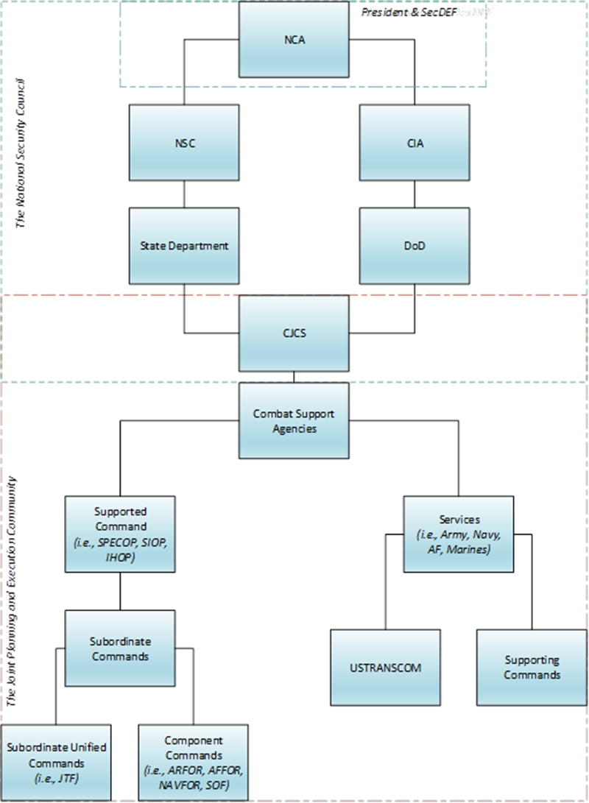

*[Figure is Unclassified]*

Figure : (U) External Organizations Relation (OV-4)

#### (U) SWIF Mission Planning Operational Scenarios (OV-5A)

(U) The following sections show example mission planning scenarios. These scenarios are intended to be examples, and not to be considered definitive of all possible scenarios.

##### (U) SWIF Generic Mission Planning Operational Scenario

(U) The following scenario is from the SWIF Web site.

*(U) NOTE: The following legacy scenarios have not yet been reviewed for accuracy or consistency against Mission Planning Capabilities or Activities sections in this document. (05/2013)*

*(****U//FOUO****) Note: Customer to verify diagram with Planner*



*[Figure is Unclassified]*

Figure : (U) Generic Mission Planning Operational Scenario

##### (U) SWIF Mission Plan Development Scenario II

(**U//FOUO**) The following is from the SWIF website

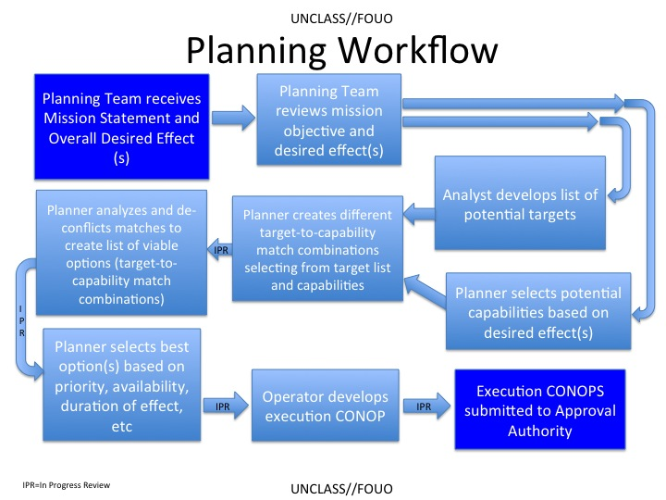

*[Figure is* ***U//FOUO****]*

Figure : (U) SWIF Mission Planning Development Scenario II

*(U) NOTE:* Another image is under development; it will be a second interpretation of the previous diagram

**(U//FOUO) SWIF Scenario and Script**

*Disclaimer: This script defines the SWIF system in an unclassified environment.*

Phase I: Problem Definition

*The Command Authority provides the mission statement and overall desired effect to the planning team. For the purposes of this scenario, the desired effect is to disrupt the power supply to a particular Northland government facility for a period of 24-48 hours. The Analysts and Planners work concurrently on their tasks; Analysts create target system and identify potential targets and the Planners create a plan and identify potential capabilities to achieve the overall desired effect.*

Phase II-A: Target System Development

*The Analyst creates a model of the adversary’s Target System Diagram (TSD) using the* ***Target System Widget****. This is a diagram describing the system that is to be disrupted. The TSD shows dependencies among system components and is used by the planner to predict the effects of plan execution on the target system. A TSD may include one or more subsystems (e.g., representing specific facilities), each of which is represented by its own subsidiary TSD diagram.*

*[Table is* ***U//FOUO****]*

| Step | Description |
| --- | --- |
| 1 | The Analyst logs in to the system.   * Analyst logs into SWIF system with username/password. |
| 2 | The Analyst starts by creating a new TSD instance in the **Target System Widget**. The Analyst loads a TSD template for the type of system that is to be affected. The Analyst will modify this generic template to describe the specific adversary TSD to be targeted.   * Analyst opens the **Target System** **Widget** and loads the “Electric Power Transmission” TSD template. * Analyst saves the TSD diagram under the name “Northland Power Supply System,” entering an appropriate security classification for the new TSD when prompted. She will only be able to save the TSD to the highest security classification as identified by Mandatory Access Control (MAC). |
| 3 | Next, the Analyst searches SWIF for information on the Northland Electrical Power Distribution System. From the **Target Search Widget**, she identifies several key facilities, including power plants, electrical substations, and key Northland government facilities.   * Analyst opens the **Target Search** **Widget** and executes a search for facilities associated with the Northlands power grid and specific manufacturing facilities of interest. Search for BENUM 1234AA5678. This will return the OSUFFIX, CATCODE, facility name, LATLON, etc. * Analyst can review the details of a target, by selecting the target and using the **Target Details Widget**. The Target Details Widget will contain all the Level 1 details, however, the Analyst will need to add additional data (Level 2) for each potential target.   Analyst drags selected facility records into the **Target System Widget** to associate the facility with a step within the TSD. The records appear as facility icons in the **Target System Widget** canvas. The facility icons reflect the type of the associated facility |
| 4 | The Analyst is prompted to add Level 2 properties to each target that has been added to the **Target System Widget**. The Level 2 properties consist of data fields that pertain to the overall desired effect, such as significance, description, expectation statement, critical elements, etc.  Planner opens the **Target Details Widget** and adds the Level 2 properties. The Analyst saves her changes and enters the appropriate security classification for the target. |
| 5 | The Analyst can create a new target by selecting a target template from the Target System toolbox. There are five types of targets and target templates: facility, individual, virtual, equipment, and organization. The Analyst must manually enter in the Level 1 data fields for each of these new targets, in addition to the Level 2 properties. Furthermore, the Analyst can add edges to each of the targets (nodes) to identify their connections within the diagram.   * Analyst clicks on a target template in the toolbox. The Target Details Widget is needed to enter the Level 1 (e.g. BENUM, OSUFFIX, Target Type, Function, etc) and Level 2 details for the target. Once complete, the Analyst saves the target and is prompted to enter the appropriate security classifications. * Analyst finds a report describing Northland power transmission lines and uses this information to connect facilities shown in the TSD diagram with lines representing (in this case) power lines. The lines can be added from the toolbox. |
| 6 | The Analyst repeats Step 3-5 until the TSD is complete. The Analyst saves the TSD, enters the overall security classification, and notifies the Planner that it’s ready for use.   * Analyst repeats Steps 3 - 5 until all of the desired targets have been identified. * Analyst selects Save to save her work. She is prompted to enter an overall security classification for the TSD. * The Analyst notifies the planner that the TSD is complete and has the filename “Northland Power Supply System.” |

*[Table is* ***U//FOUO****]*

Phase II - B: Operational Planning

*The Planner develops an initial operation plan based on the overall mission statement and desired system effect as provided by the Command Authority. Once the Analyst provides the Target System, the Planner can attach it to the plan and the identified targets will become part of the initial planning phase. The Planner is responsible for identifying potential capabilities that will achieve the overall desired effect. The Planner will review the Target System to determine the intended and unintended consequences of attacking various targets and then match capabilities to targets to achieve the desired effect(s).*

*[Table is* ***U//FOUO****]*

| Step | Description |
| --- | --- |
| 1 | The Planner logs in to the system.   * Planner logs into SWIF system with username/password. |
| 2 | The Planner next opens the **Plan Editor Widget** and creates a new (blank) plan document.   * Planner opens **Plan Editor**and enters the following data:   1. Plan Name: “Interrupt Power to Northland BE123456”   2. Mission Statement: “The primary goal of this mission is to...”   3. Desired System Effect: “The intent is to provide a localized ….”   4. Mission Status: “Pending” (optional)   5. Mission Start / End Date (optional)   Click save and specify the security classification. |
| 3 | The Planner opens the Capability Search Widget to search for capabilities that will achieve the overall desired effect. The Planner can review the details of a capability by selecting on the capability and using the Capability Details Widget. Once the Planner has identified a desirable capability, he drags it to the Plan Editor Widget. Repeat process until all desired capabilities have been added to Plan.   * Planner opens Capability Search Widgets. * Planner enters “XXXX” and clicks “Search” button. * Planner selects a capability and views the capability’s details in the Capability Detail Widget.   Planner decides this is a potential capability to achieve the desired effect. Planner drags the XXXX capability to the Capability Options on the Plan Editor Widget. |
| 4 | Planner receives the Target System from the Analyst. Planner attaches the Target System to the **Plan Editor Widget** to view the Target System Diagram and the identified targets are added to the plan.   * Planner attaches the Target System to the Plan Editor Widget by clicking on the “browse” button and selecting “Northland Power Supply System.” * The targets identified in the Target System are added to the Plan Editor under Target Nomination. |
| 5 | The Planner reviews the TSD provided by the Analyst, paying particular attention to the critical components she has identified.   * Planner opens **Target System Widget** and opens TSD “Northland Power Supply System.” * Planner clicks on various components of the TSD to highlight them and view the details. It’s also possible to open any associated documentation (e.g., JWICS-derived reports) the Analyst has attached to the selected TSD nodes. |
| 6 | The planner decides to conduct a CARVER analysis on a few of the potential targets identified in the Target System.   * Planner opens the CARVER Widget. Planner drags the desired targets to the CARVER widget. * Planner enters the following CARVER values, sorts on different columns, such as column "C" (for Criticality), and then sorts on the Total column:  |  |  |  |  |  |  |  |  | | --- | --- | --- | --- | --- | --- | --- | --- | | **Potential Target** | **C** | **A** | **R** | **V** | **E** | **R** | **Total** | | Transformer | 5 | 3 | 3 | 5 | 5 | 5 | 26 | | SCADA Controller | 5 | 3 | 5 | 4 | 3 | 5 | 25 | | Switch | 3 | 5 | 3 | 5 | 5 | 3 | 24 | | Bus Coupler | 3 | 4 | 5 | 2 | 2 | 2 | 18 | | Breaker | 1 | 1 | 3 | 1 | 2 | 2 | 10 | |
| 7 | The Planner identifies which targets are “nominated targets” by checking them in the Target Nomination section of the Plan Editor Widget. These nominated targets can be used for matching when creating options.   * Planner selects the check box next to each desired target to nominate it for matching (Plan Editor Widget). |
| 8 | Next the Planner begins to match Capabilities to the Targets in the **Plan Editor: Targeting Tab.** Planners can view a matrix that contains all the nominated targets and potential capabilities. This matrix will have white and gray squares indicating their match potential (white is a perfect match; gray is a questionable match). The Planners will coordinate with the Joint Targeting Board for deconfliction. The Joint Targeting Board will identify targets as “unrestricted / restricted / no-strike.” For each valid match, the Planner is required to enter additional instructions and notes for the CONOP development.   * Planner opens the Targeting Tab of the **Plan Editor Widget**. All of the nominated targets and identified capabilities appear in a matrix. The planners are able to select any of the squares (even if they are gray). Once the planner receives the final “ok” from the Joint Planning Board, the Planner selects the corresponding row/column to identify a valid capability-target match. * Planner enters notes for each capability-target match, which will be useful during CONOP development. The Planner enters the target effect, system effect, and implementation notes for that capabilities   1. Target Effect: “The intended effect on the target is...”   2. System Effect: “The intended overall effect on the system is...”   Implementation Notes: “SME, I want you to provide...” |
| 9 | Based on the identified capability-target matches, the Planner creates a schedule of events. The Planner drag and drops the matches from the matrix onto the Schedule to generate a Gantt Chart that summarizes the Plan. The Planner organizes the Targets and associated capabilities according priority (y-axis) and time (x-axis). The planner can link the targets with lines that depict dependencies, sequencing, re-attack requirements, and other icons that depict external events as required. Once completed, this is saved as an “option” within the plan.   * Planner drags and drops the capability-target matches from the matrix onto the schedule. * Planner begins dragging the individual targets horizontally, to specify their associated capability execution time, and vertically, to indicate their priority. * Planner can add external events and lines to indicate a sequence of events. * Planner clicks “Save,” Specifies the security classification, and saves this particular option under the name “Option 1.”   [Note: Options are discrete components of Plans, and each Plan can have multiple alternate Options associated with it. Options may have lower security classification levels than their parent Plan because they may not include some higher security level capabilities that are present in the parent plan.] |
| 10 | The Planner now generates two additional options by repeating step 8 and step 9.   * Planner resets the capability-target matrix. * Planner repeats Steps (8) and (9), creating two additional different options, saving them under the names “Option2” and “Option3,” each with their own security levels. |
| 11 | The Planner identifies the best Option and flags it as the “final” Option. The planner notifies each operator that a CONOP will be needed based on his or her capability expertise. The operator will receive a request to create a CONOP and/or appendix for the final Option.   * Planner identifies the final option and clicks the CONOP button to send the request to the operator for weaponeering. |

*[Table is* ***U//FOUO****]*

Phase III: CONOP/Appendix Development

*Once the Planner has completed the development of their final option, he marks identifies it as the final option. SWIF notifies the associated capability POC(s) (Execution Operators) that there is a request for weaponeering and a CONOP and/or Appendix will need to be generated for their corresponding capability-target assignments. The operators log in to SWIF to complete this work.*

| Step | Description |
| --- | --- |
| 1 | Each Capability Operator logs in to SWIF.   * Operator logs into SWIF system with username/password |
| 2 | The Operator opens the **CONOP Widget**. The **CONOP Widget** automatically shows all Plans that include Capabilities assigned to the Provider. The operator uses the **CONOP Widget** to create a CONOP for each related capability.   * Operator opens the **CONOP Widget** and browses the Plans that have been assigned to them. * Operator selects and opens a particular Plan. The Plan summary and details are presented in the **CONOP Widget**. * Operator optionally opens the **Target System Widget** to review the overall strategy. * Operator opens a particular option and then selects a specific Target that is matched to the Operator’s capability. The Provider can now read the desired effect and implementation notes as specified by the Planner. * Operator uses the **CONOP Widget** to create a CONOP for each assigned Target. * Operator saves the CONOP, specifying the appropriate security classification.   The CONOPs/Appendix are automatically attached to the final Option in the associated Plan and the originating Planner is notified that the CONOPs have been completed. The Planner can view the status of the requested CONOPs/Appendix and they can access the **CONOP Widget**, in a read-only state, to review the documentation provided by the operator. Once all the CONOPs have been received, the Planners can prepare to brief the final Option to the Command Authority. |

**NOTES**

1) All users (analysts, planners, and operators) of the SWIF database will only be able to view data and widgets based on their MAC. Single sign-on is implemented for all widgets that a user can access. Any time a user clicks "save" in any widget that creates or modifies data they will be prompted to identify the security classification and level of that data.

2) JWAC input:

Target-capability match should have:

* BDA- Battle Damage Indicator
* BDA- Battle Damage Assessment

Both may be provided by other agencies that don't have MAC but do have their own security label system.

##### (U//FOUO) SWIF Mission Plan Development Scenario (OV-5A)

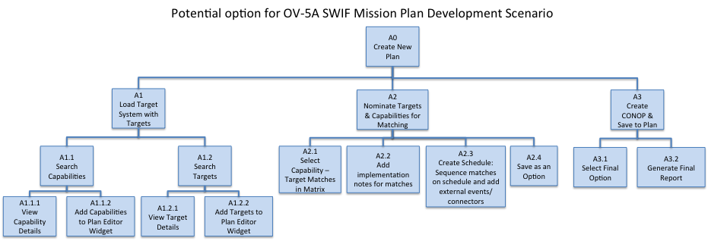

*[Figure is* ***U//FOUO****]*

#### (U//FOUO) SWIF Mission Plan Development Scenario (OV-5B)

(U) The following diagram is from SWIF Web site.

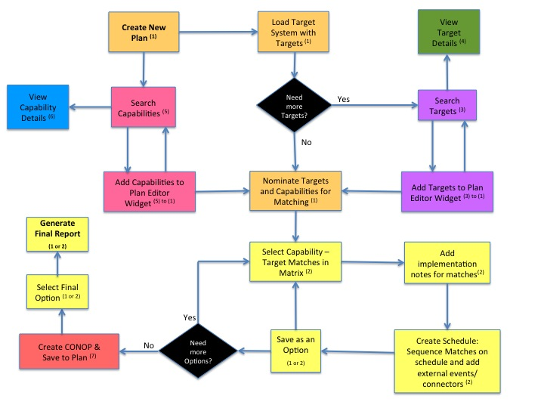

*[Figure is* ***U//FOUO****]*

Figure (U) SWIF Plan Development Scenario (OV-5B)

Table : (U//FOUO) SWIF Plan Development Scenario Legend

*[Table is* ***U//FOUO****]*

|  |  |  |
| --- | --- | --- |
| **Color** | **Widget** | **Notes** |
| **(1)** | **Plan Editor: Summary Tab** | Create plan, add mission statement, desired effects, dates, and nominate capabilities and targets. Save and select final plan/option |
| **(2)** | **Plan Editor: Scheduling Tab** | Select capability-target matches in matrix, sequence matches to create schedule, add implementation notes, and add external events/connectors. Save and select final plan/option. |
| **(3)** | **Target Search** | Search for Targets. Drag and drop to Plan Editor Widget to add to Plan |
| **(4)** | **Target Details** | Displays target details whenever a target is selected (i.e. Target Search Widget and within the Plan Editor). Two modes: Read and Edit. |
| **(5)** | **Capability Search** | Search for Capabilities. Drag and drop to Plan Editor Widget to add to Plan |
| **(6)** | **Capability Details** | Displays capability details whenever a target is selected (i.e. Capability Search Widget and within the Plan Editor) |
| **(7)** | **CONOP Editor** | Create CONOP for a capability-target match within a plan. CONOP will be saved within the associated plan. |

*[Table is]*

##### (U) Analyst Workflow Scenario (OV-5B)

(U) The following is from SWIF website.

Table : (U) Analyst Workflow Scenario (OV-5B)

*[Table is* ***U//FOUO****]*

| Step | Description |
| --- | --- |
| 1 | The Analyst logs into SWIF (OWF) |
| 2 | The Analyst opens the TSA Widget and creates a new Target System Diagram (TSD), assigns it a name, and enters descriptive metadata. Analyst gives it a security classification level based on their MAC. |
| 3 | The Analyst searches MIDB for Northland Electric Power Facilities, etc., and drags selected items into TSA canvas. |
| 4 | The Analyst refers to ancillary intelligence on the Northland power system (using JWICS) and uses the data to guide connections of previously added Facilities to define Northland power grid. |
| 5 | The Analyst needs to create a new Target from a template. Analyst drags an icon from system component palette into the canvas. Once the Analyst saves the TSD, all of the data will be inserted into the SWIFDB and the user is prompted for the security classification. |
| 6 | The Analyst opens a Target for editing and adds information. The Analyst performs the CARVER Analysis on several potential targets. Analyst saves edits to the SWIFDB. |
| 7 | The Analyst drags the potential targets to the Candidate Targets List and requests Vetting & Validation. Once validated, targets are automatically removed from the Candidate Targets List and reappear in the Valid Targets List. |
| 8 | The Analyst saves Target System Diagram and is prompted to enter overall classification level. |

*[Table is* ***U//FOUO****]*

##### (U) Planner Workflow Scenario (OV-5B)

(U) The following is from SWIF website.

Table : (U) Planner Workflow Scenario (OV-5B)

*[Table is* ***U//FOUO****]*

| Step | Description |
| --- | --- |
| 1 | The Planner logs into SWIF. The Planner opens the Plan Editor Widget and creates a new Plan document, assigns it a name, enters descriptive metadata in the Plan Summary fields, and adds the Analyst’s TSD. |
| 2 | The Planner opens the TSA Widget and browses the TSD prepared by the Analyst. The Planner reviews the CARVER analysis on the selected targets, and then flags several for targeting. |
| 3 | In the Plan Editor Widget, the Planner drags targets from the Valid Target List to the Nominated Target List so that they can be further evaluated for the Course of Action (COA). |
| 4 | The Planner selects a target in Nominated Targets List and assigns one or more Capabilities to it. At the same time, Planner enters the desired effect and implementation notes for each Capability added, which will be conveyed to the Provider after the final COA is selected. |
| 5 | The Planner does not see their desired capability from the pre-populated list so the Planner creates a new Capability from scratch. New capabilities are saved within the plan only. |
| 6 | The Planner switches to the Target Conflicts Widget and deconflicts/downselects capability assignments to arrive at a desired subset for a specific COA. |
| 7 | The Planner opens the Targeting Schedule Widget and arranges and links Targets (& associated Capabilities) to create a Gantt Chart-like diagram. |
| 8 | The Planner saves this particular set of Target/Capability assignments and the timeline as a discrete COA. The Planner develops and saves additional alternate COAs. |
| 9 | The Planner picks the final COA and requests are sent the provider to create the CONOP/Appendix. |

##### (U) Provider Workflow Scenario (OV-5B)

(U) The following is from SWIF website.

Table : (U) Provider Workflow Scenario (OV-5B)

*[Table is* ***U//FOUO****]*

| Step | Description |
| --- | --- |
| 1 | The Capability Provider logs into SWIF. The Provider receives request for weaponeering, logs into SWIF, and opens the Provider Widget. Provider browses the list of assigned Target-Capability matches and creates a CONOP/Appendix for each one. |
| 2 | Provider saves prepared CONOP(s) to the SWIF database; the CONOP automatically attaches to the designated COA in the associated Plan. |
| 3 | The Planner can view the status of the CONOPs/Appendix for the chosen COA and they can view the documentation provided by the capability providers in the Provider Widget (read-only). Once the planner receives all the completed CONOPs, they can brief the chosen COA to the Command Authority. |

Table is UNCLASSIFIED//FOUO

##### (U) Visualization Scenario (OV-5B)

(U) The following is from SWIF website.

***Phase I:*** Analyst needs to develop the visualization diagram to help him identify the relationships between targets and their associated political entities.

Table : (U) Provider Workflow Scenario (OV-5B)

*[Table is* ***U//FOUO****]*

| Step | Description |
| --- | --- |
| 1 | Analysts can read in the network data from a flat file, database connection, or synapse data store.   * The flat file is transferred from an outside network via a standard transfer process. The Administrator will apply the appropriate security label when he transfers the flat file into the database. Then the Analyst can load the data into the visualization widget. |
| 2 | Analyst runs the algorithm. This will generate a diagram with nodes and edges spatially placed according to the strength of their relationship.  Analyst clicks button to run the algorithm. This generates a visualization diagram. |
| 3 | The Analyst is able to draw conclusions from visually looking at the visualization diagram and identify areas of concern that may need further evaluation. He should be able to identify large groups and the connections between groups. Also, if data is time coded, the analyst can identify chaining (events occurring in a specific sequence, e.g., look for if node A talks to C immediately after talking to B). |
| 4 | Analyst is able to view the network diagram, which depicts the edges as a relationship and the nodes as peoples, places, or things. The details of these nodes and edges are based on the metadata from the imported file.   * Analyst clicks on the edge A-B, which will display the details of that relationship within the Focus Widget. * Analyst clicks on node A to identify the details of this node in the Focus Widget. |

*[Table is* ***U//FOUO****]*

***Phase II:*** Analyst can change the visualization diagram and run various scenarios:

Table : (U) Visualization Scenario (OV-5B)

*[Table is Unclassified]*

| Step | Description |
| --- | --- |
| 1 | Analyst is able to apply a coloring scheme to both nodes and edges according to their attributes.   * Analysts runs a filter on the visualization diagram to identify all the male politicians. The analyst goes to attribute drop down, |
| 2 | Analyst is able to apply a gradient color scheme to numeric data within the visualization widget (ex. Reflects varying levels of impact based on color: ranges from light purple to red)   * Analyst chooses to identify how violent a particular group is. The analyst can select to apply a gradient color scheme based on the number of violent incidents. Nonviolent groups will appear in purple and very violent groups will appear as red. |
| 3 | Analyst can filter by high degree nodes (nodes with many connections).  Analyst runs the filter to show nodes with more than 10 connections. Analyst runs the Degree Centrality Calculator and then applies the color "red" to the metric results |
| 4 | Analyst can filter by bridge nodes (nodes with only 1 connection to other nodes with many connections) .  The analyst needs to calculate the bridge score to identify the bridge nodes. The Analyst runs the Betweenness Centrality Calculator to find all the paths in a network and identify those node with lots of edges. Then the analyst identifies the bridge nodes by applying the color "green" to the metric results |
| 5 | Analyst wants to apply a "What if" analysis by removing a relationship (removes a node or edge). User can then view before and after.  Analyst removes edge A-B and watches how the diagram is modified. |
| 6 | If data is time coded, user can watch how a network has built up over time. Visualize growth/decay (time encoded data). The visualization widget is able to auto extract dates from the nodes and edges, which are displayed in a timeline bar.  Analyst is able to scroll through the timeline bar to show how events have grown / decayed over time. In addition, he can set the timeline to auto play with a specified speed so that he can watch how diagram evolves over the time period specified. |

*[Table is Unclassified]*

#### (U//FOUO) SWIF Planning Operational Activities (OV-5B)

(U) These activities are intended to depict a high level example of these activities. The actual design of these activities is intended to be documented in the respective SDD.

##### (U) Create CONOP Activity (OV-5B)

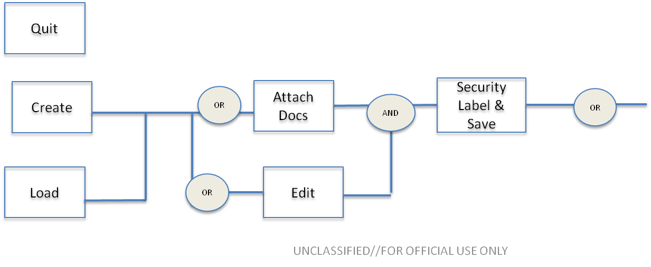

*[Figure is* ***U//FOUO****]*

Figure . (U) Create CONOP (OV-5B)

##### (U) Modify CONOP Activity (OV-5B)

(U) To be completed.

##### (U) Associate Plans to CONOPS Activity (OV-5B)

(U) To be completed.

##### (U) Receive Tasking Request Activity (OV-5B)

(U) To be completed.

[Figure is Unclassified]

Figure : (U) Receive Tasking Request Activity (OV-5b)

##### (U//FOUO) Create Plan Activity (OV-5b)

(**U//FOUO**) The following is from the SWIF Web site.

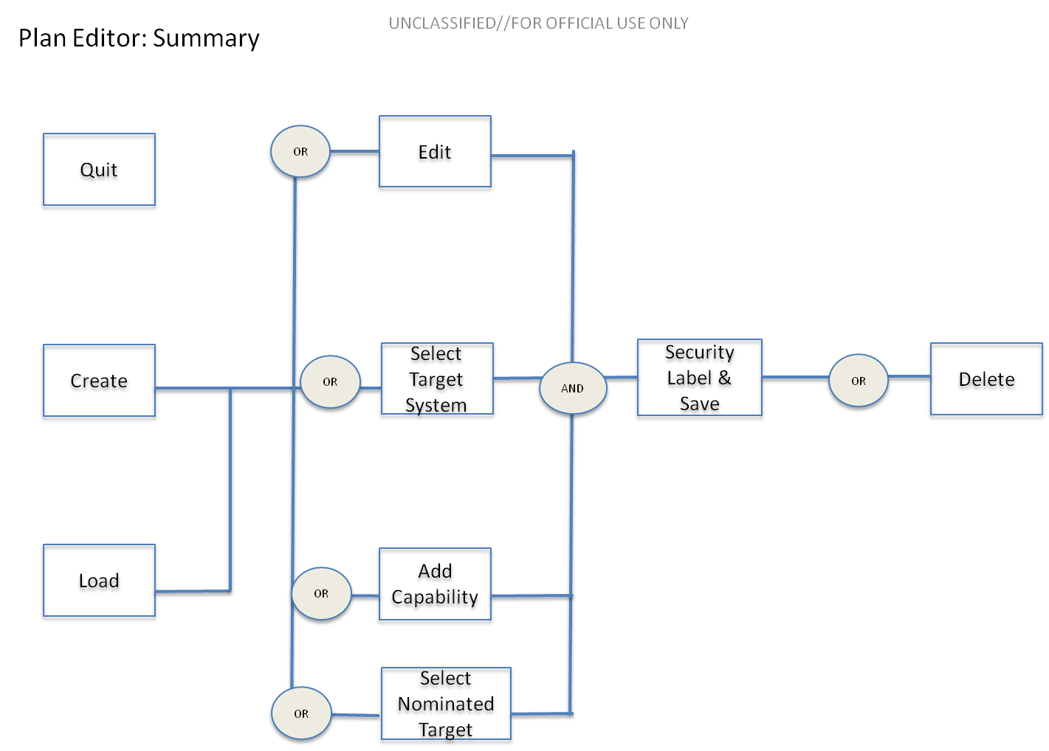

*[Figure is* ***U//FOUO****]*

Figure : (U) Plan Editor: Summary (OV-5B)

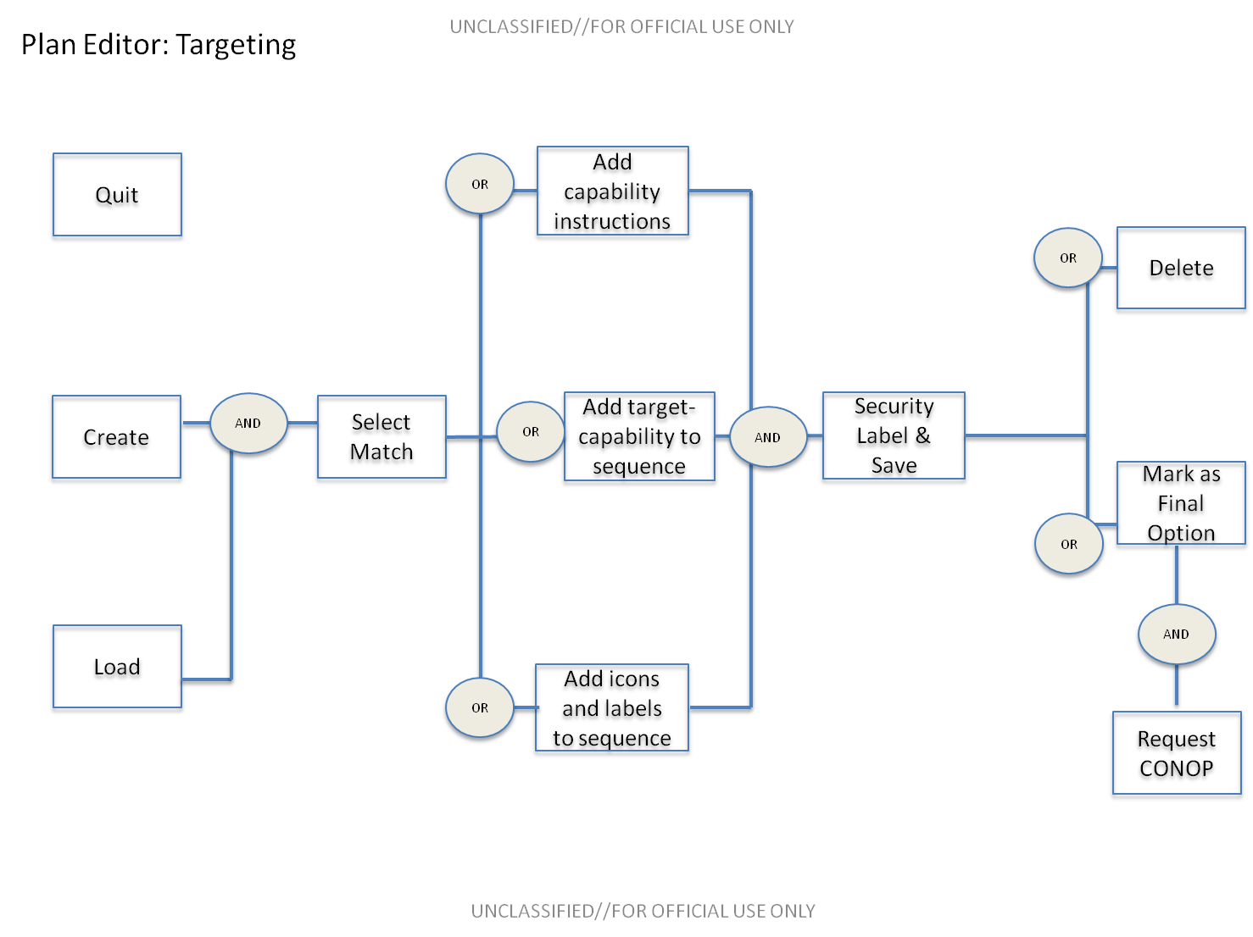

*[Figure is* ***U//FOUO****]*

Figure : (U) Plan Editor: Targeting (OV -5b)

##### (U) Modify Plan Activity (OV-5B)

(U) To be completed

##### (U) Create Report Activity (OV-5B)

(U) To be completed.

Figure : (U) Create Report Activity (OV-5B)

##### (U) Associate Entities Activity (OV-5B)

(U) The following images represent two examples of associating entities to Plans and are from the SWIF website.

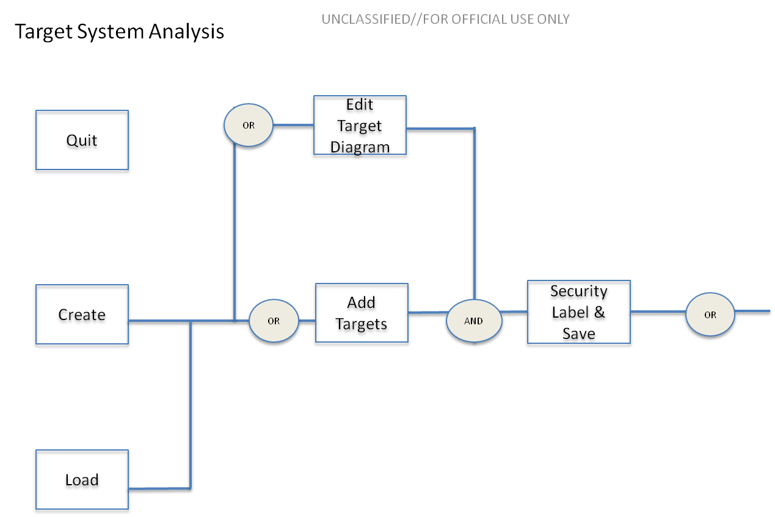

*[Figure is* ***U//FOUO****]*

Figure : (U) Associate Targets Activity (OV-5B)

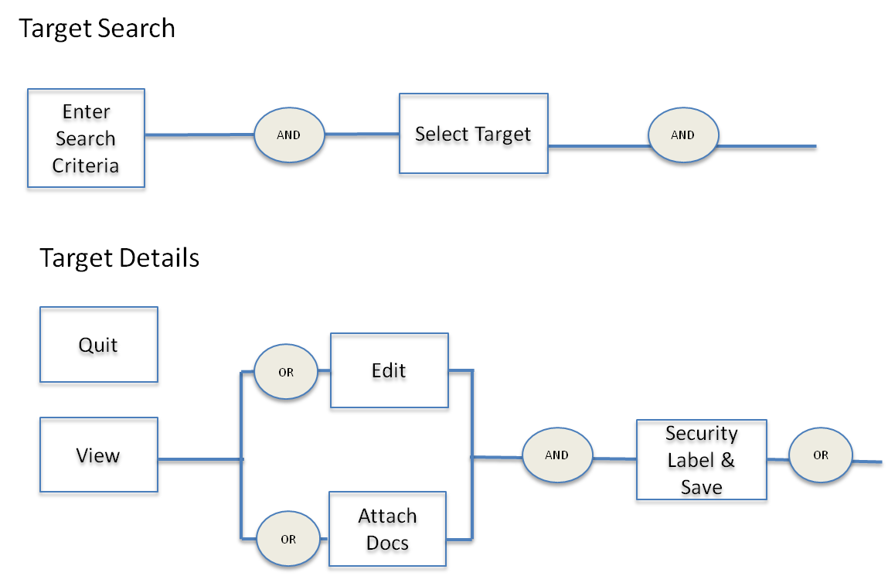

*[Figure is Unclassified]*

Figure : (U) Associate Targets Activity (OV-5B)

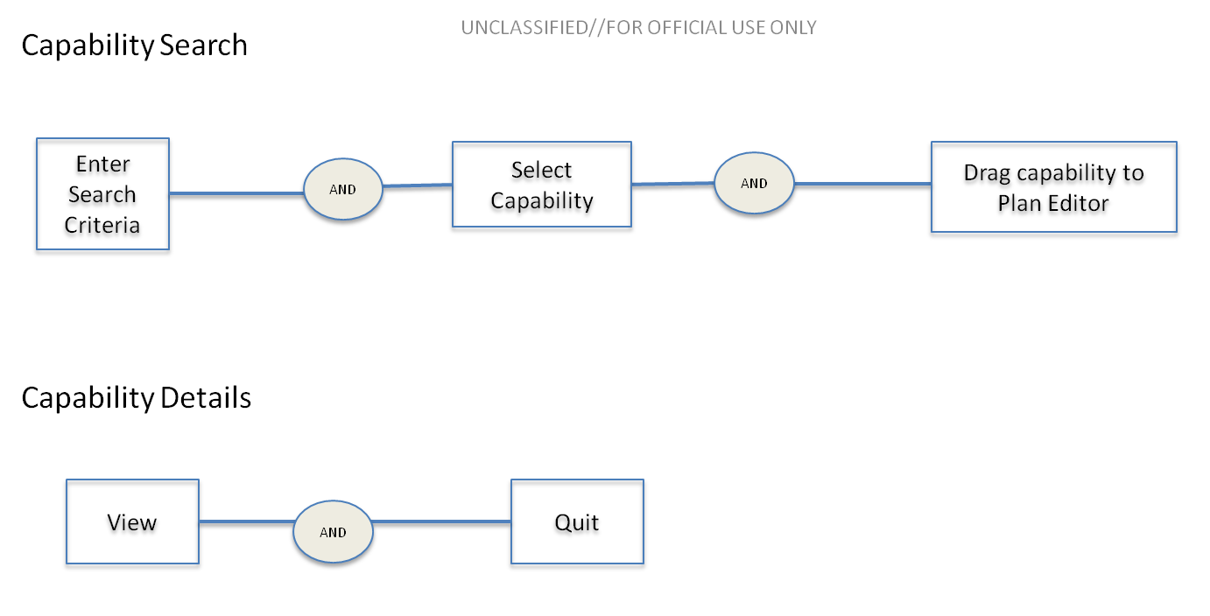

*[Figure is* ***U//FOUO****]*

Figure : (U) Associate Capabilities Activity (OV-5B)

##### (U) Analytics Activity (OV-5B)

(U) To be completed.

Figure : (U) Analyze Targets and Capabilities Activity (OV-5B)

##### (U) Visualization Activity (OV-5B)

(U) To be completed.

Figure : (U) Analyze Targets and Capabilities Activity (OV-5B)

#### (U) SWIF Targeting Operational Activities (OV-5B)

(U) These activities are intended to depict a high level example of these activities. The actual design of these activities are intended to be documented in the respective SDD.

(U) To be completed.

#### (U) SWIF Capability Operational Activities (OV-5B)

(U) These activities are intended to depict a high level example of these activities. The actual design of these activities are intended to be documented in the respective SDD.

(U) To be completed.

## (U) Services Viewpoint

(U) This section will outline both the SWIF Core Services and the SWIF Planning and Targeting Services Viewpoints.

### (U) SWIF Common Services

#### (U) SWIF Common Services Context Description (Svc-1)

(U) To be completed.

#### (U) SWIF Common Services Resource Activities (Svc-2)

(U) To be completed.

#### (U) SWIF Common Services Functionality Description (Svc-4)

(U) To be completed.

### (U//FOUO) SWIF Planning Services

(U) To be completed.

#### (U//FOUO) SWIF Planning Services Context Description (Svc-1)

(U) To be completed.

#### (U//FOUO) SWIF Planning Services Resource Activities (Svc-2)

(U) To be completed.

#### (U//FOUO) SWIF Planning Services to Service Matrix (Svc-3)

(U) To be completed.

#### (U//FOUO) SWIF Planning Services Functionality Description (Svc-4)

(U) To be completed.

### (U) SWIF Target Services

(U) To be completed.

#### (U) SWIF Target Services Context Description (Svc-1)

(U) To be completed.

#### (U) SWIF Target Services Resource Activities (Svc-2)

(U) To be completed.

#### (U) SWIF Target Services to Service Matrix (Svc-3)

(U) To be completed.

### (U) SWIF Capability Services

(U) To be completed.

#### (U) SWIF Capability Services Context Description (Svc-1)

(U) To be completed.

#### (U) SWIF Capability Services Resource Activities (Svc-2)

(U) To be completed.

#### (U) SWIF Capability Services to Service Matrix (Svc-3)

(U) To be completed Capability

#### (U) SWIF Capability Services Functionality Description (Svc-4)

(U) To be completed.

## (U) Systems Viewpoint

(U) This section will outline both the SWIF System Viewpoint.

### (U) SWIF Systems Interface Description (SV-1)

*(U) NOTE:* Remove ‘External Network’ nodes

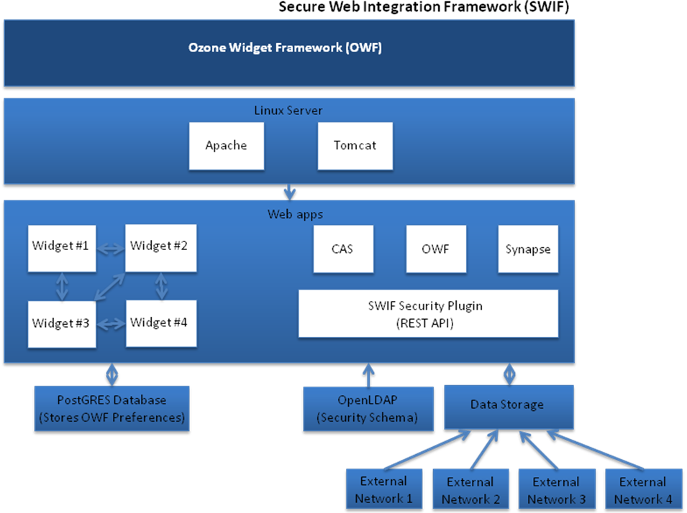

*[Figure is Unclassified]*

Figure : (U) SWIF Systems Interface Description

### (U) SWIF Systems Resource Description (SV-2)

(U) To be completed.

### (U) SWIF System to System Matrix (SV-3)

*.*

# (U) REQUIREMENTS TRACEABILITY

(U) To be completed when Requirement Draft (SSS) is finalized.

# (U) NOTES

## (U) Abbreviations (AV-2)

*(U) NOTE: This AV-2 is not yet complete.*

| **ACRONYMS AND ABBREVIATIONS** | |
| --- | --- |
| ABAC | Attribute Based Access Control (ABAC) |
| ADAAG | Americans with Disabilities Act Accessibility Guidelines for Buildings and Facilities |
| CAS | Central Authentication Service |
| CIA | Central Intelligence Agency |
| CJCSI | Chairman of the Joint Chiefs of Staff Instruction |
| CLI | Call Level Interface |
| CMP | Configuration Management Plan |
| CONOP | Concept of Operations |
| COP | Common Operational Picture |
| CRUD | Create, Read, Update, Delete |
| CRUDA | Create, Read, Update, Delete, Archive |
| CV | Capability Viewpoint |
| DAC | Discretionary Access Control |
| DBDD | Database Design Description |
| DCID | Director of Central Intelligence Directive |
| DD | Design Decision |
| DICAP | DoD Information Assurance Certification and Accreditation Process |
| DID | Data Item Description |
| DISA | Defense Information Systems Agency |
| DoD | Department of Defense |
| DoDAF | Department of Defense Architecture Framework |
| DoDD | Department of Defense Directive |
| DoDI | Department of Defense Instruction |
| EPO | Engineering Process Office |
| FIPS | Federal Information Processing Standard |
| FISMA | Federal Information Security Management Act |
| FOUO | For Official Use Only |
| GOSS | Government Open Source Software |
| HWCI | Hardware Configuration Item |
| IBS | Integrated Broadcast System |
| ICD | Intelligence Community Directive |
| ICD | Interface Control Document |
| IEC | International Electrotechnical Commission |
| ISM | Information Security Markings |
| ISO | International Organization for Standardization |
| JSON | JavaScript Object Notation |
| JTF | Joint Task Force |
| MAC | Mandatory Access Control |
| MIL | Military |
| NAI | Named Area of Interest |
| NIST | National Institute of Standards and Technology |
| OV | Operational View |
| OWF | OZONE Widget Framework |
| P.L. | Public Law |
| PL-3 | Protection Level 3 |
| PM | Program Manager; Project Manager |
| RDT&E | Research, Development, Test and Evaluation |
| REST | Representational State Transfer |
| SDD | Software Design Description |
| SDP | Software Development Plan |
| SOF | Special Operations Forces |
| SPAWAR | Space and Naval Warfare |
| SQL | Structured Query Language |
| SRR | Security Readiness Review |
| SSDD | System/Subsystem Design Description |
| SSS | System /Subsystem Specification |
| STDV | Standards Viewpoint |
| STIG | Security Technical Implementation Guides |
| SV | System Viewpoint |
| Svc | Service |
| SWIF | Secure Web Integration Integrated Framework |
| TSA | Target System Analysis [widget] |
| TSD | Target System Diagram |
| UAM | User Account Management |
| UFAS | Uniform Federal Accessibility Standards |
| UI | User Interface |
| UML | Unified Modeling Language |
| USTRANSCOM | United States Transportation Command |
| XML | Extensible Markup Language |

## (U) Definitions (AV-2)

| SWIF Roles | Definition/Abilities |
| --- | --- |
| General User | A system role whereby the user can access all system functionality that is not administrative in nature and that is authorized for their organization. This will be constrictive in nature and is based on their type of organization. All roles within SWIF are General User roles with exception of Site and Organization Administrators. |
| Privileged User | A system role whereby the user can access all system functionality, including administration, authorized for the system. Privileged user roles include Site and Organization Administrators. |
| Operator | A system role whereby the user can perform the full scope of create, read, update, delete, archive (CRUDA) operations within the system with exception of administrative tasks. |
| Site Administrator | A system role whereby the user is responsible for site-level administrative tasks that encompass the host site and that impact all using organizations. |
| SSO | A system role whereby the user verifies the security clearance of the individual requesting access to the SWIF system. The SSO will verify the requester’s clearance level, compartments, and releasability information. |
| External System | A system role assigned to user accounts that are external systems enabling those systems to access specific SWIF web services. |
| Viewer | A system role whereby the user can perform read-only operations within the system with exception of administrative tasks. |
| Group Manager | A system role whereby the user can perform CRUDA operations for Groups. (e.g. Manage Workflows) |
| System User | This system role is reserved for internal system component actions only and is not available for assignment to users. |

(U) APPENDIX A – Mission Planning Widget Mockups

(U//FOUO) Appendices A and B are legacy mockups. The following Appendix contains mockups of widgets to support Mission Planning, and are from the SWIF Web site:

A.1 (U//FOUO) Plan Editor: Summary Tab

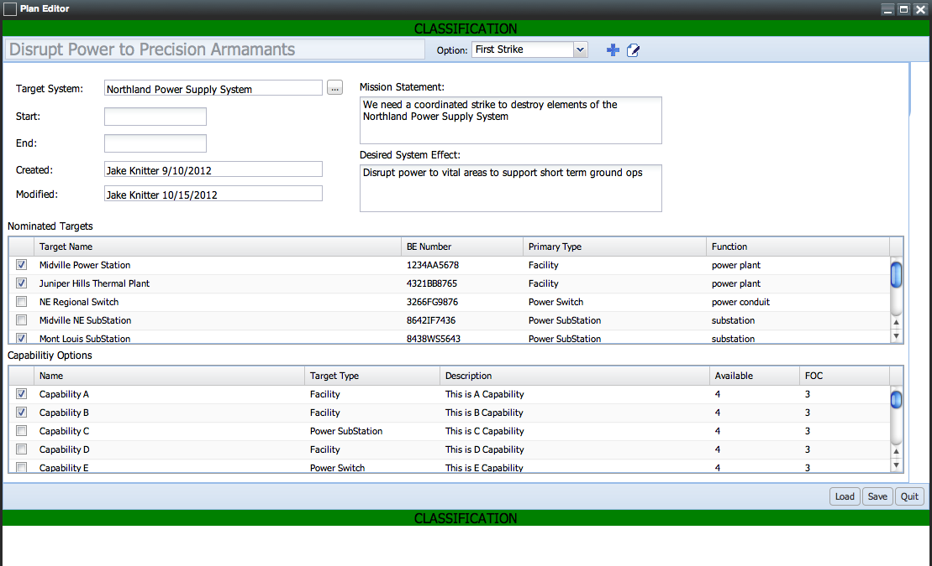

[Figure is **U//FOUO**]

Figure : (U) Widget Mockup: Plan Editor: Summary Tab

A.2 (U//FOUO) Plan Editor: Scheduling Tab

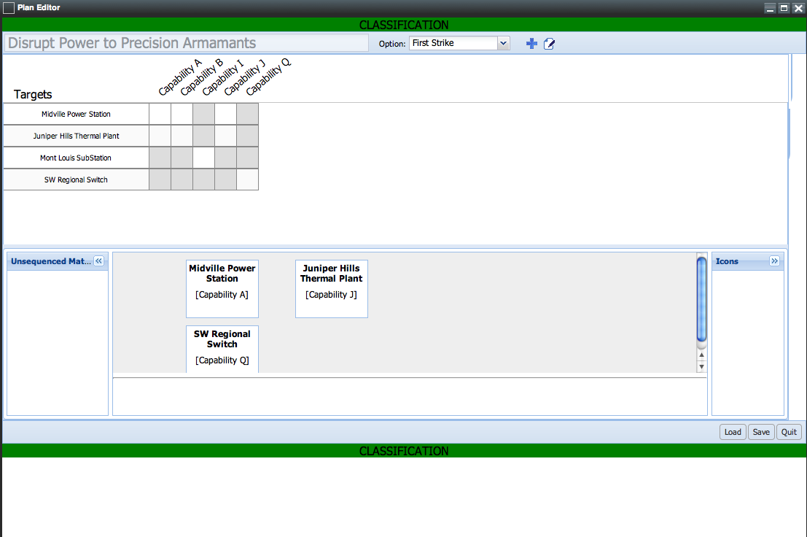

*[Figure is* ***U//FOUO****]*

Figure : (U) Widget Mockup: Plan Editor: Scheduling Tab

A.3 (U) Target Search

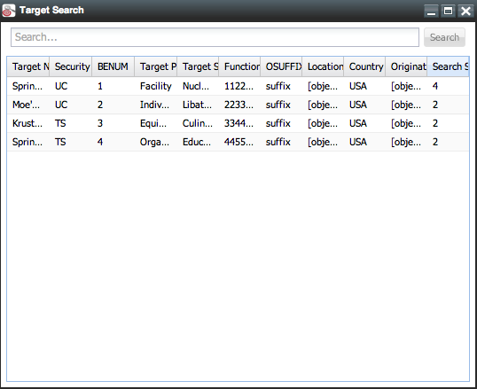

*[Figure is Unclassified]*

Figure : (U) Widget Mockup: Target Search

A.4 (U) Target Details: Read Mode

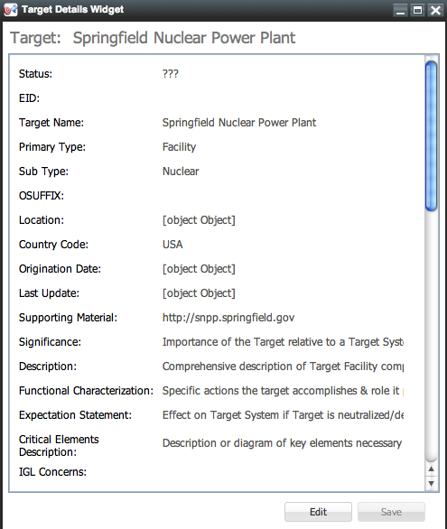

*[Figure is Unclassified]*

Figure : (U) Widget Mockup: Target Details Read Mode

A.5 (U) Target Details: Edit Mode

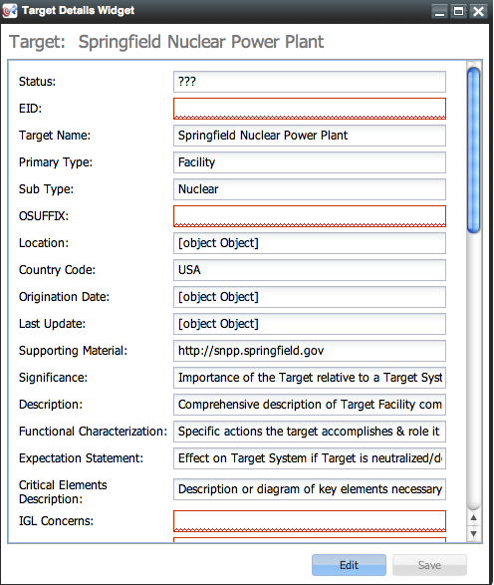

*[Figure is Unclassified]*

Figure : (U) Widget Mockup: Target Details Edit Mode

A.6 (U) Capability Search

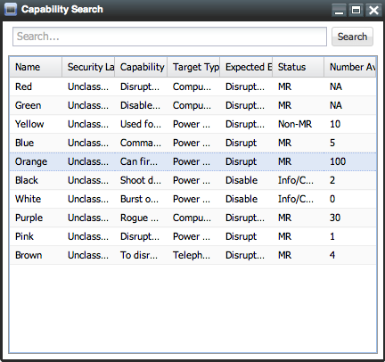

*[Figure is Unclassified]*

Figure : (U) Widget Mockup: Capability Search

A.7 (U) Capability Details

*[Figure is Unclassified]*

Figure : (U) Widget Mockup: Capability Details

A.8 (U) CONOP Editor

*[Figure is Unclassified]*

Figure : (U) Widget Mockup: CONOP Editor

(U) APPENDIX B – General Planning Workflow and Widget Mockups

(U) Appendices A and B are legacy mockups The following Appendix contains mockups of widgets to support a General Mission Planning Workflow. The following is from the SWIF website

B.1 (U) General Planning Workflow

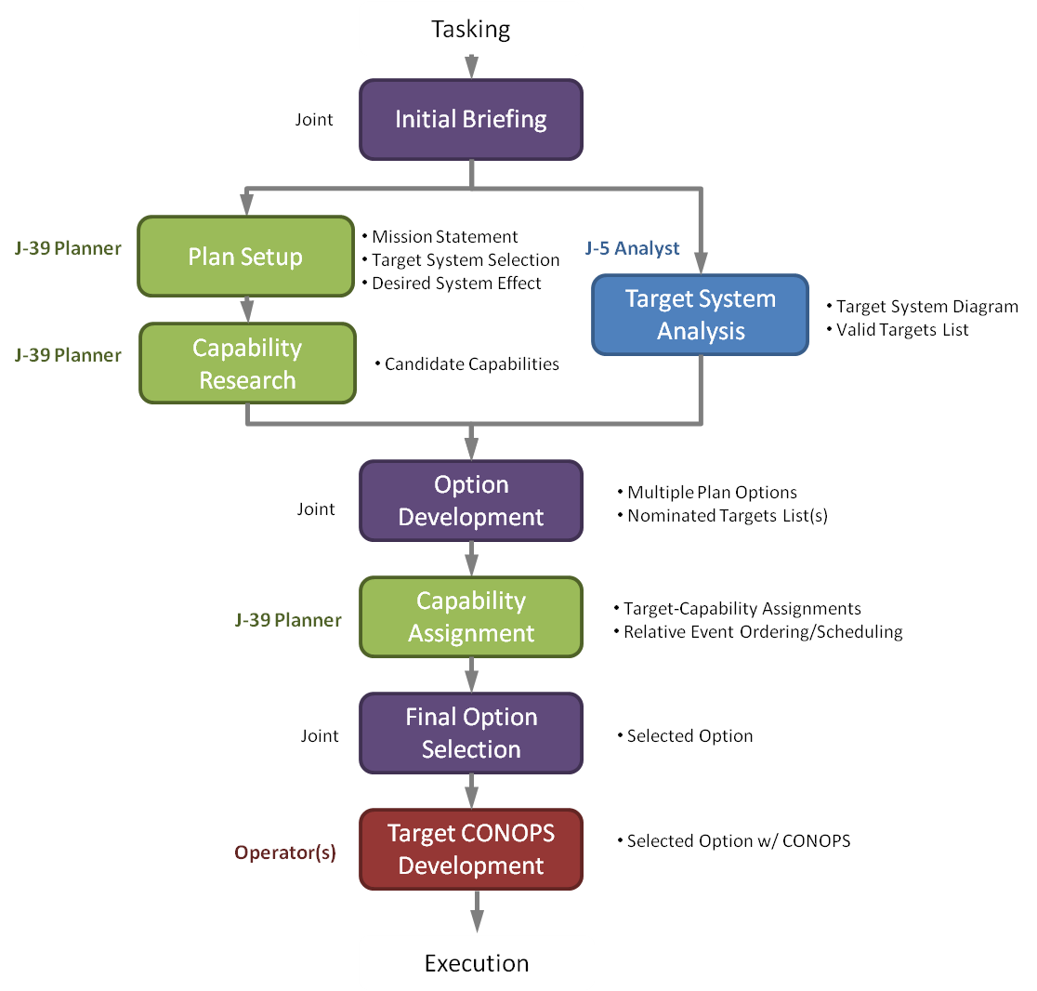

*[Figure is* ***U//FOUO****]*

Figure : (U//FOUO) General Planning Workflow

B.2 (U//FOUO) Plan Editor Widget

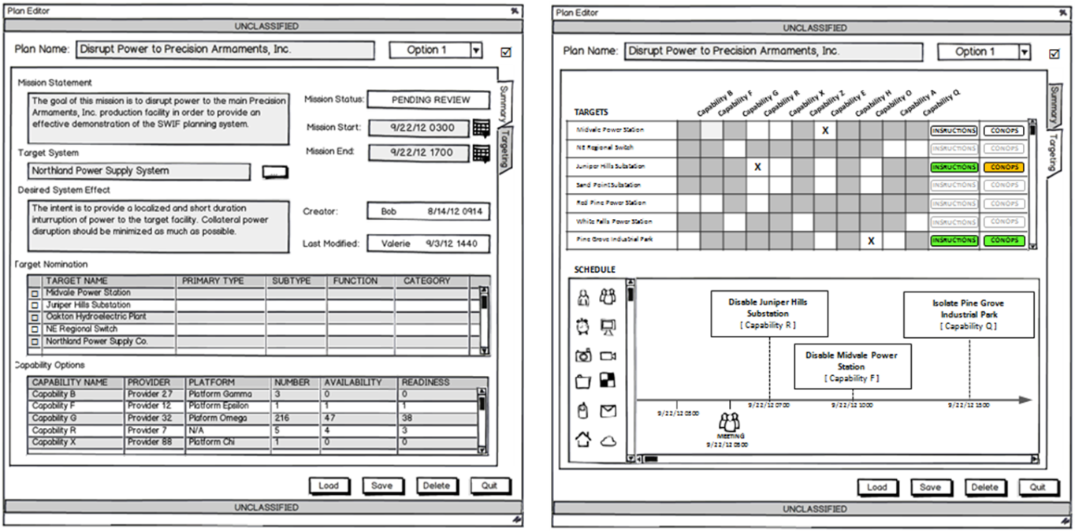

*[Figure is U//FOUO]*

Figure : (U//FOUO) Plan Editor Widget

B.2 (U) Plan Editor Widget

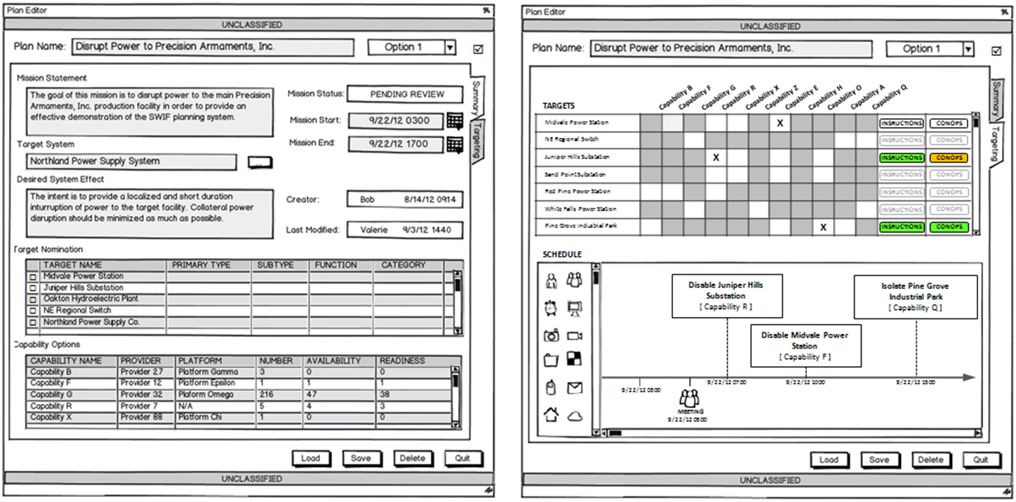

*[Figure is U//FOUO]*

Figure : (U//FOUO) Plan Editor Widget

B.3 (U//FOUO) Plan Setup

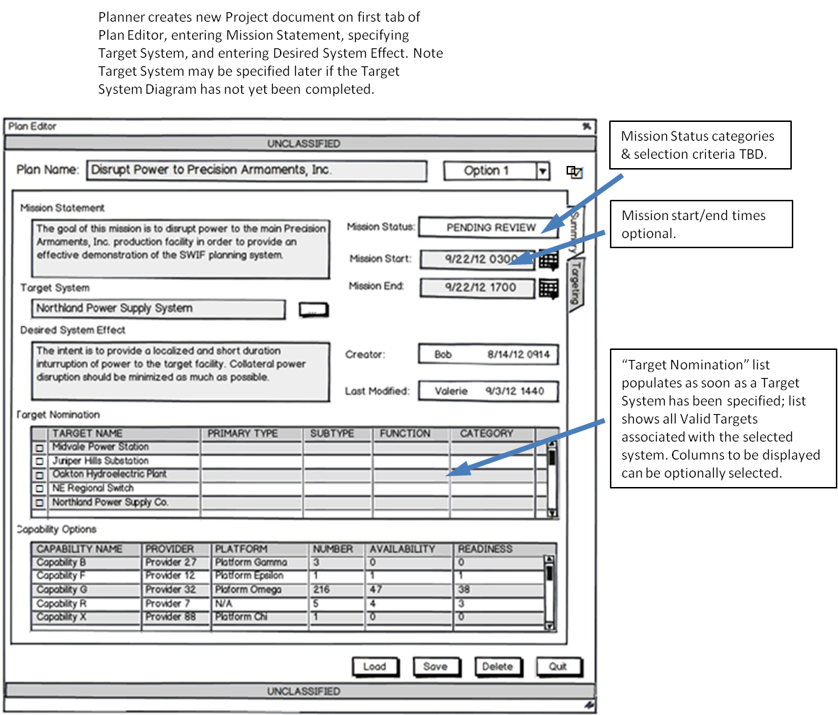

*[Figure is U//FOUO]*

Figure : (U//FOUO) Plan Setup

B.4 (U) Capability Research

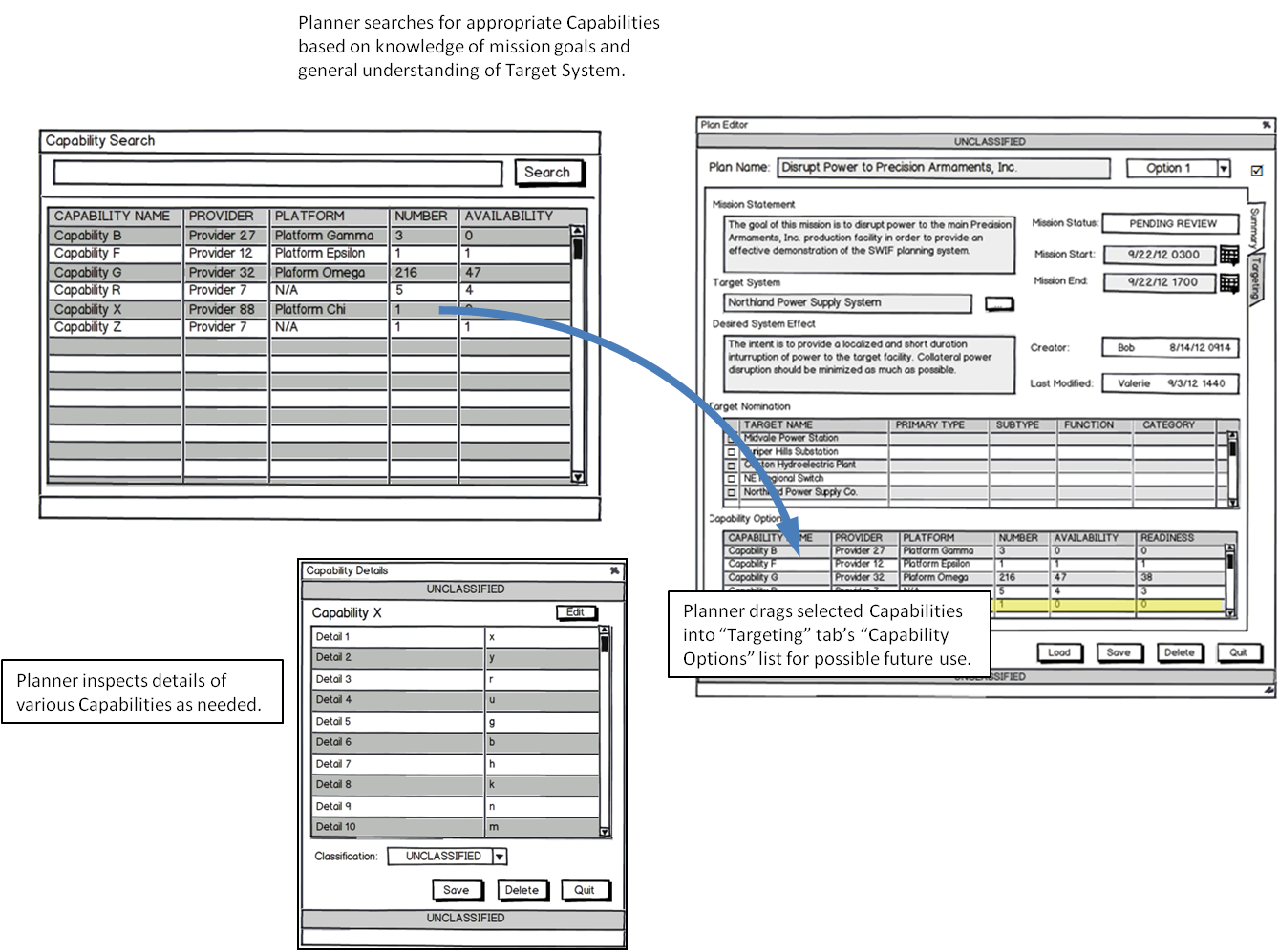

*[Figure is Unclassified]*

Figure : (U) Capability Research

B.5 (U) Target System Analysis

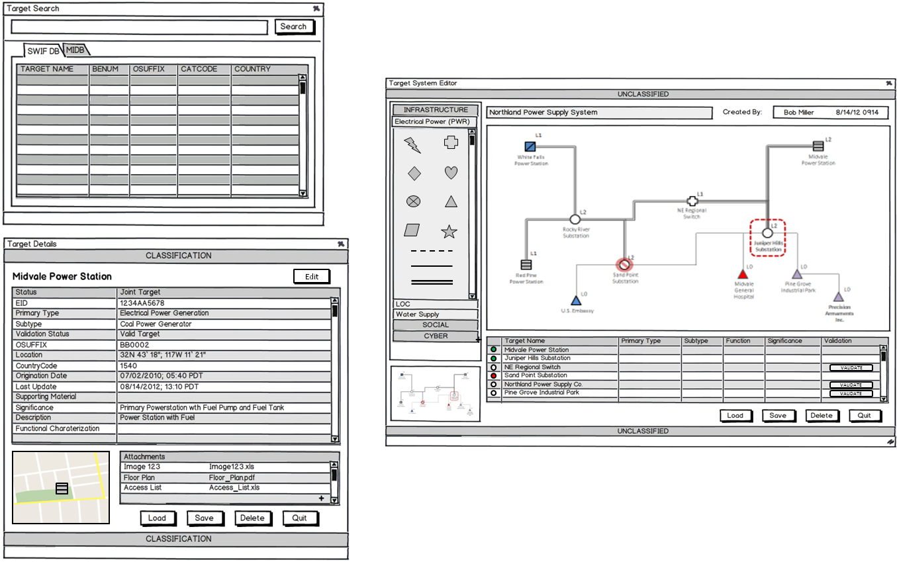

*[Figure is Unclassified]*

Figure : (U) Target System Analysis

B.6 (U) Target System Analysis

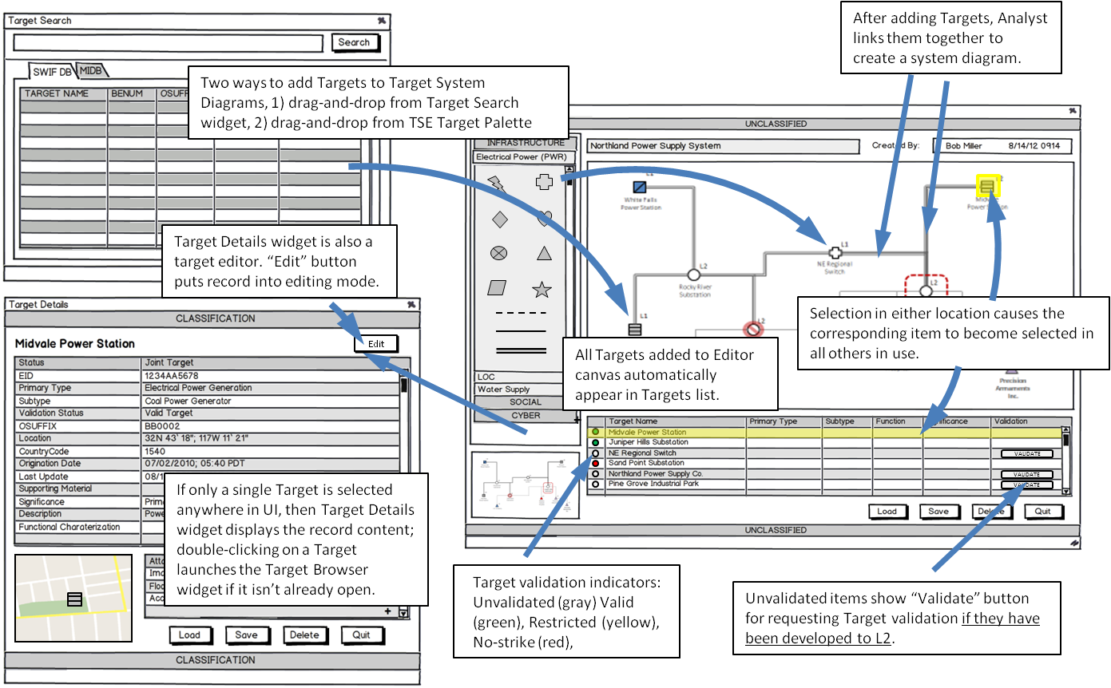

*[Figure is Unclassified]*

Figure : (U) Target System Analysis

B.7 (U) Option Development

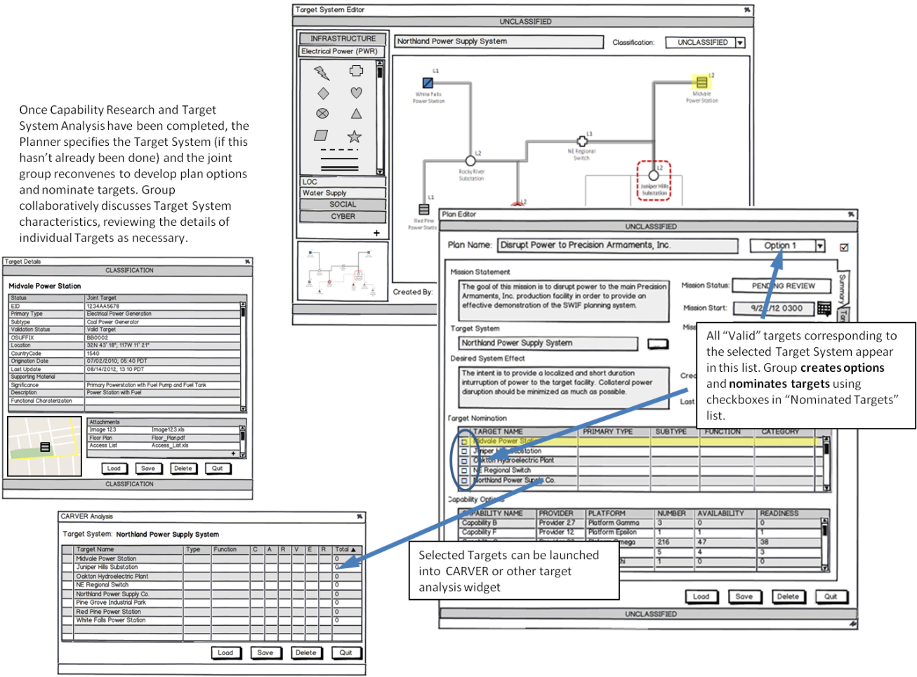

*[Figure is Unclassified]*

Figure : 7 (U) Option Development

B.8 (U) Capability Assignment

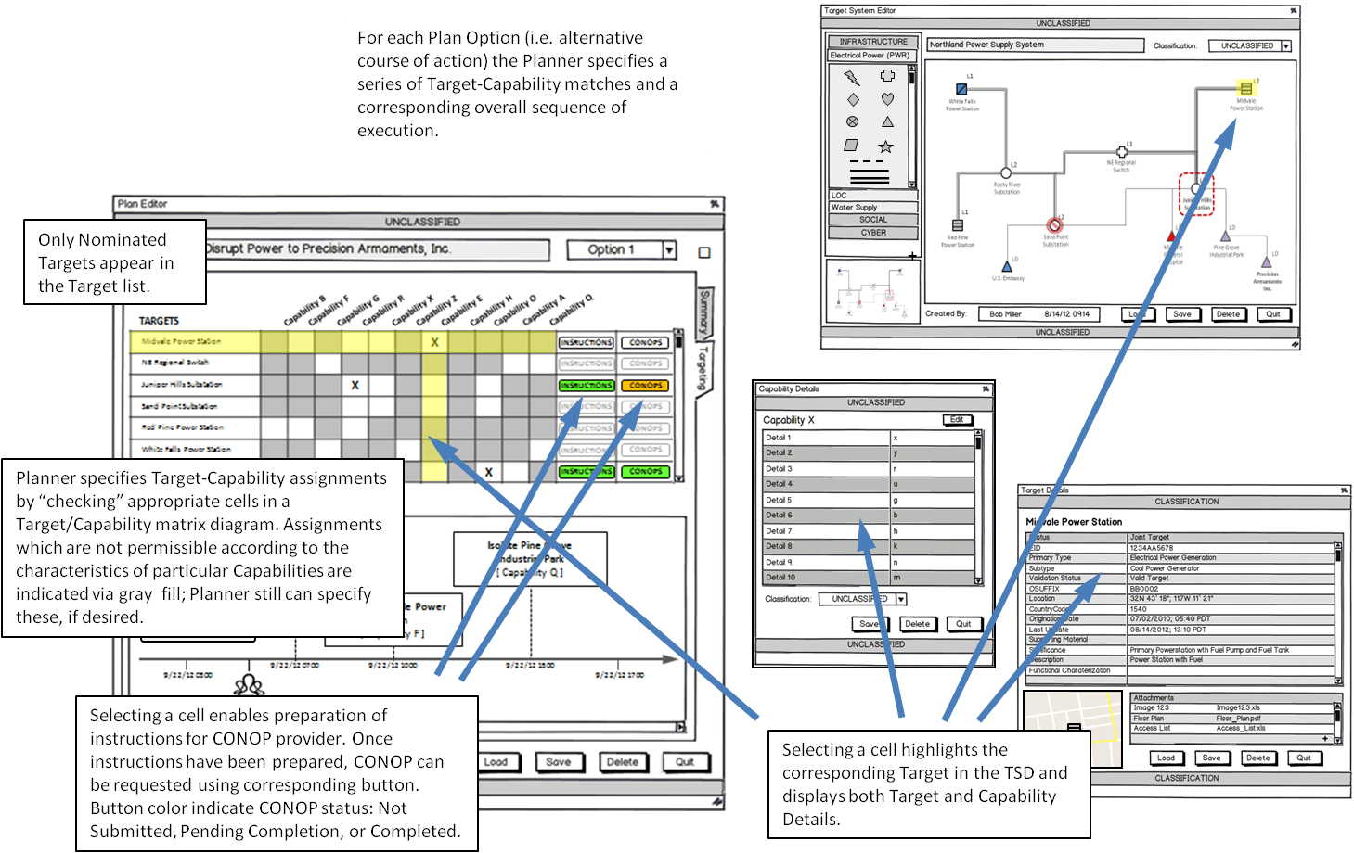

*[Figure is Unclassified]*

Figure : (U) Capability Assignment

B.9 (U) Capability Assignment

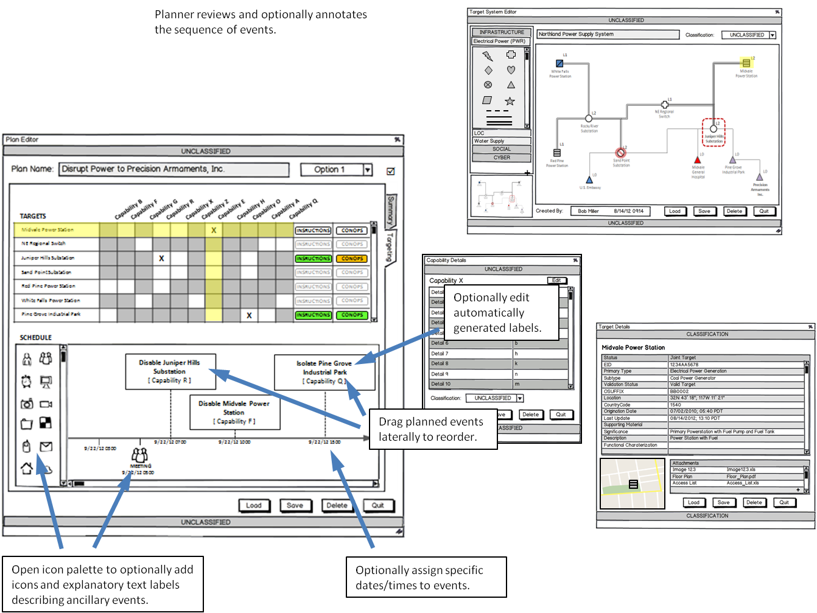

*[Figure is Unclassified]*

Figure : (U) Capability Assignment

B.10 (U) Final Option Selection

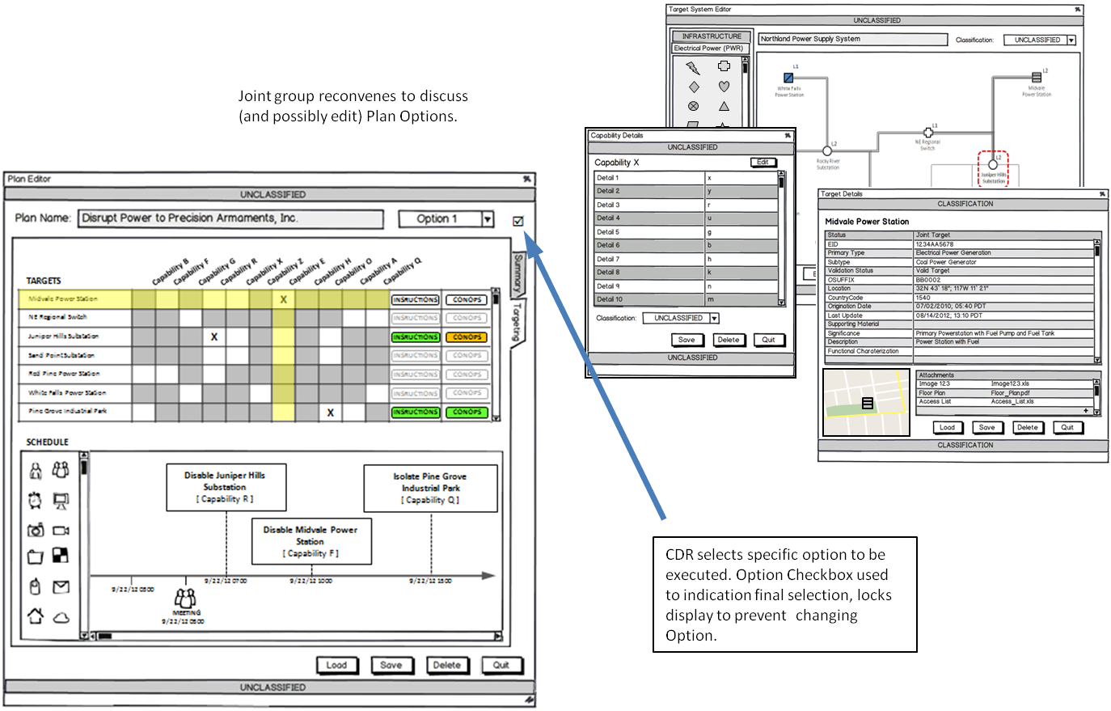

*[Figure is Unclassified]*

Figure : (U) Final Option Selection

B.11(U) Target CONOPS Development

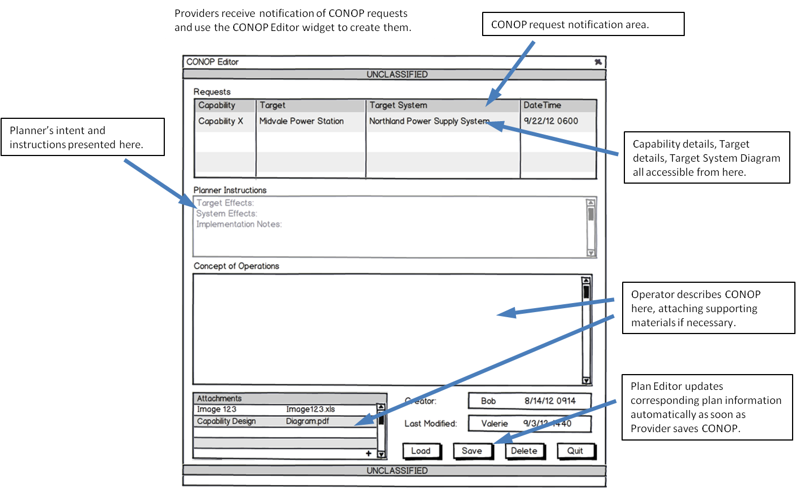

*[Figure is Unclassified]*

Figure : (U) Target CONOPS Development

B.12(U) SWIF Widget Set

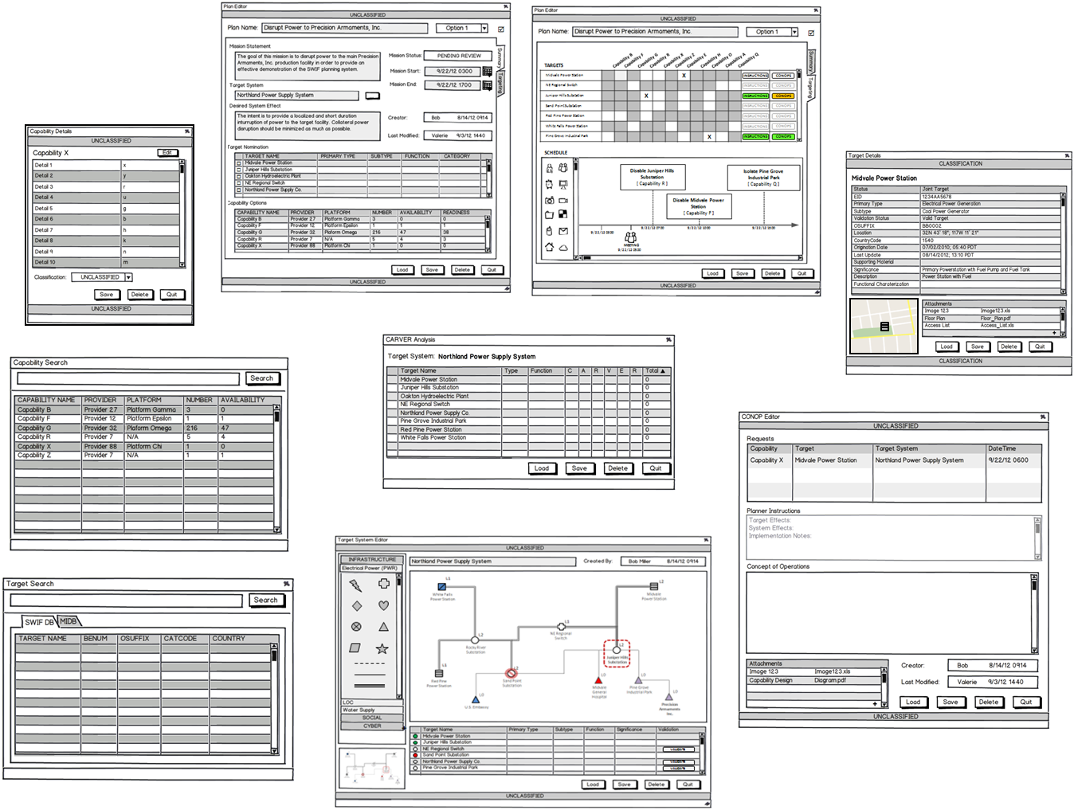

*[Figure is Unclassified]*

Figure : (U) SWIF Widget Set

B.13 (U//FOUO) Plan Edit Widget Summary

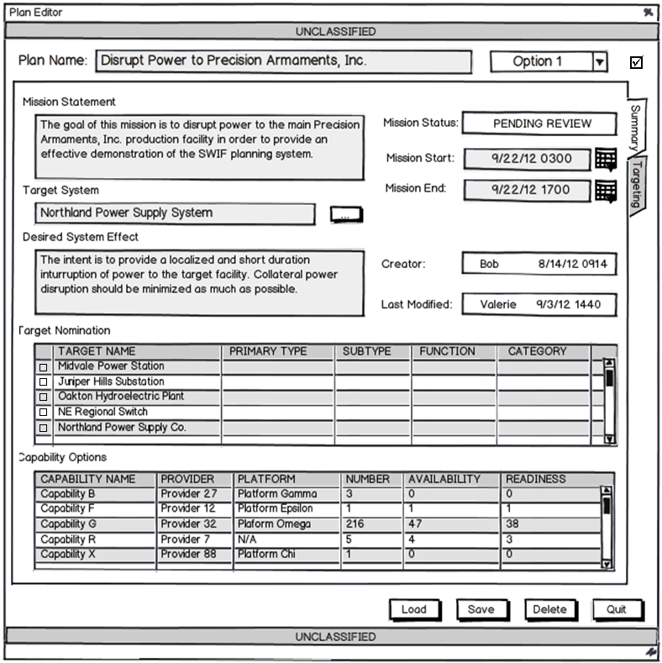

*[Figure is* ***U//FOUO****]*

Figure : (U//FOUO) Plan Edit Widget Summary

B.14 (U//FOUO) Plan Editor Widget, Targeting Tab

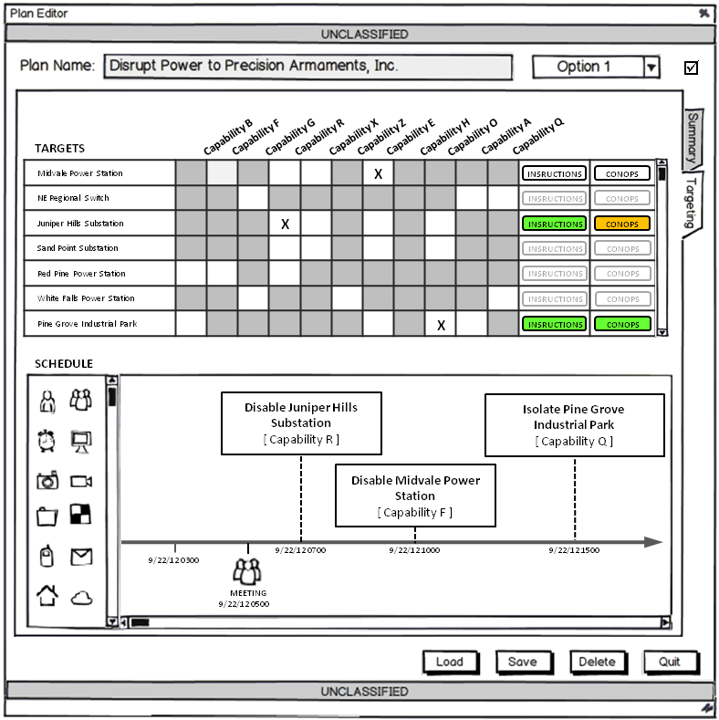

*[Figure is U//FOUO]*

Figure : (U//FOUO) Plan Editor Widget, Targeting Tab

B15 (U) L1 Targeting Properties

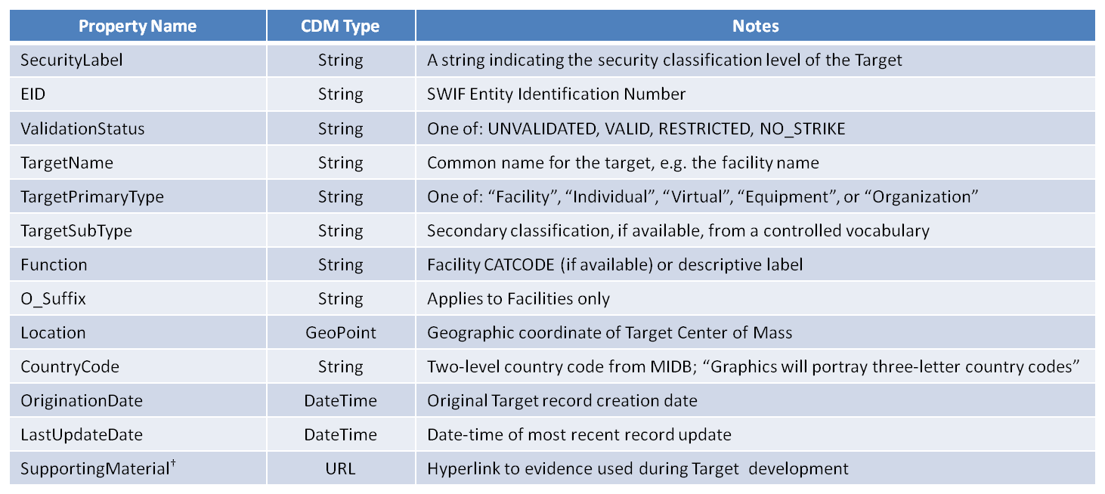

*[Figure is Unclassified]*

Figure : (U) L1 Targeting Properties

B.16 (U) L2 Targeting Properties

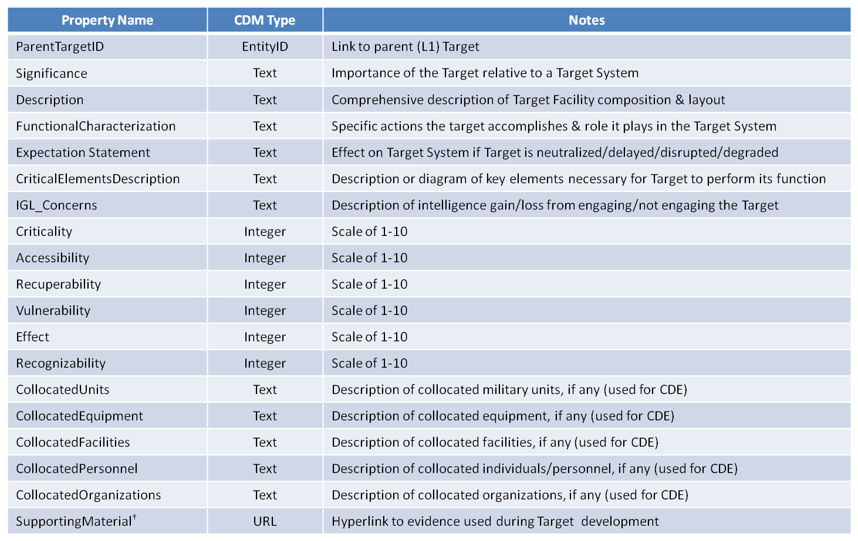

*[Figure is Unclassified]*

Figure : (U) L2 Targeting Properties

B.17 (U) L3 Targeting Properties

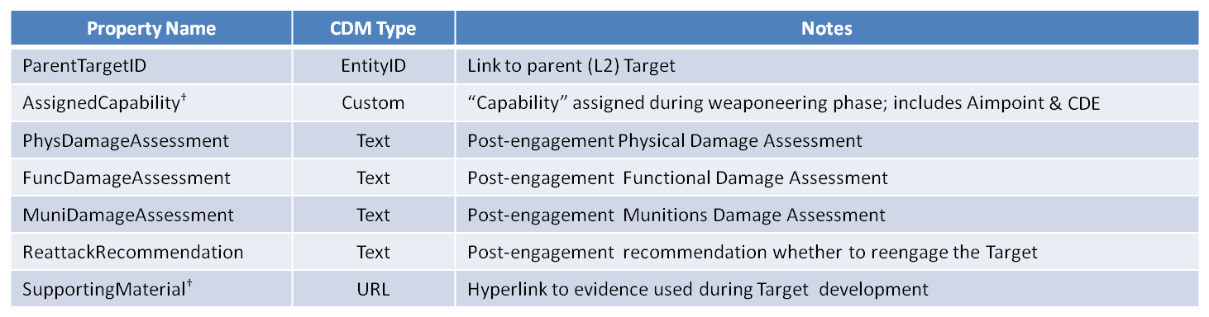

*[Figure is Unclassified]*

Figure : (U) L3 Targeting Properties

B.18 (U//FOUO) Analyst Workflow

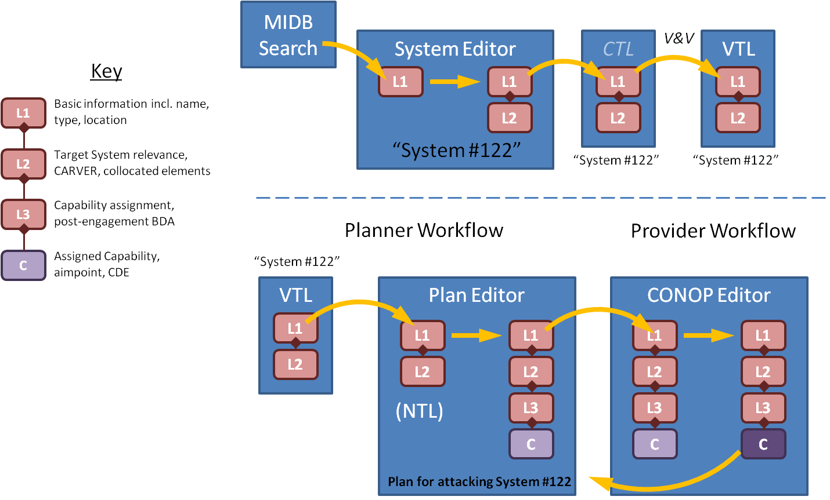

*[Figure is* ***U//FOUO****]*

Figure : (U) Analyst Workflow